***SOUTHEASTERN***

***FOOTBALL OFFICIALS***

***ASSOCIATION***



***Mechanics Manual for***

***Crews of 6 Officials***

***\*\*FINAL WORKING DRAFT\*\****

***August 2022***

***www.sefoa.net***

***https://www.facebook.com/sefoafootball/***

**TABLE OF CONTENTS**

**BASIC OFFICIATING GUIDELINES: 4**

**GAME AND PLAY CLOCKS: 4**

**MERCY RULE: 4**

**END OF HALF AND OVERTIME PERIODS: 4**

**BETWEEN 1ST AND 2D / 3D AND 4TH QUARTERS: 5**

**TIMEOUTS: 7**

**PENALTY SITUATIONS: 8**

**MEASUREMENTS: 10**

**READING AND UNDERSTANDING KEYS: 12**

**GENERAL GUIDELINES: 12**

**KEYS AT SNAP AND FORMATIONS: 13**

**PRE-GAME: 19**

**OFF THE FIELD DUTIES: 19**

**ON THE FIELD DUTIES: 19**

**COIN TOSS MECHANICS: 21**

**FREE KICK: 23**

**KICKOFF (REGULAR): 23**

**KICKOFF (ONSIDE): 27**

**SCRIMMAGE PLAYS: 25**

**BEFORE THE SNAP: 32**

**RUNNING PLAYS: 36**

**PASSING PLAYS: 40**

**SCRIMMAGE KICKS: 44**

**GOAL LINE PLAYS: 51**

**GOAL LINE PLAYS INSIDE THE 7-YARD LINE: 51**

**GOAL LINE PLAYS INSIDE 25-YARD LINE BUT OUTSIDE THE 7-YARD LINE: 54**

**FIELD GOALS AND TRY FOR POINT: 58**

**AFTER THE GAME: 62**

**BASIC OFFICIATING GUIDELINES:**

**GAME AND PLAY CLOCKS:**

• Side Judge is responsible for the backup on-field game clock.

• In the event the field game clock malfunctions or the game management provided clock operator is unqualified, the Side Judge will have the primary game clock and the Line Judge will provide backup on-field game clock. The clock will stop and referee give a four-minute warning at the end of the second and fourth quarter to both teams.

• Field Judge is responsible for the 25/40 second play clock and will signal the ten second countdown. The Field Judge will also time timeouts and intermissions between scores and periods.

• Review NFHS General Instructions for Football Game and Play Clock Operations published annually.

**MERCY RULE:** Guidelines for using a running clock are defined in VHSL Handbook and Policy.

• FOOTBALL POINT RULE: when a thirty-five (35) point differential is reached at half-time or at any point during the second half, the game clock will continue to run anytime there is an incomplete pass, the runner goes out of bounds or the offensive team obtains a first down. Additionally, when the mercy rule is in effect and there is a:

• Change of possession the clock will stop for substitutions and setting the chains and then start on the "ready for play" signal.

• Score, the clock will stop for the extra point. The clock will run by rule during the subsequent free kick, then after setting the chains, started on the "ready for play" signal.

• Charged timeout, the clock will stop and then start on the "ready for play" signal following the timeout.

• Should the point differential subsequently be reduced to less than thirty-five points, game officials will discontinue the use of this timing adjustment. This adoption will be utilized during regular season and playoff games and at all levels of play (varsity and sub-varsity). This adjustment may not be utilized when NFHS Football Rule 3-1-3 is in effect.

**END OF HALF AND OVERTIME PERIODS:**

Referee and Umpire:

• Verify there are no fouls that require an untimed down.

• Determine any penalties that may carry over to 2d half or overtime period.

Short Wings:

• Determine which end that 2d half kicking team will defend.

• Inform Head Coach of any fouls that will carry over to 2d half or overtime period.

• Inform Head Coach of length of halftime or intermission before overtime period.

Deep Wings:

• Ensure teams exiting at halftime remain separated if exiting same end of field.

All Officials:

• Meet with Referee to review 1st Half and discuss 2d Half actions, or;

• Meet with Referee at center of field to review overtime procedures.

**BETWEEN 1st AND 2D / 3D AND 4TH QUARTERS:**

Referee:

• Verify there are no fouls that require an untimed down.

• Note team in possession, down, distance, clip location and yard line and lateral position of the ball on the field, then confirm with the Umpire and Head Linesman.

• Note above on your game card, and move to the opposite end of the field.

• Check with the Linesman and Umpire when spotting the ball.

• Ensure only the proper player/coach conferences occur.

• Give the ready-for-play signal when 60 seconds have expired.

• Reconfirm down, distance and field position.

• Count A players.

Umpire:

• Record the following information on your game card: team in possession, down, distance, clip location and yard line and lateral position of the ball on the field.

• Secure new ball from Field Judge.

• Move to the opposite end of the field to spot the ball accurately on the field.

• Check the number of time outs remaining and confirm it with the crew.

• Remain over the ball until the Referee releases you prior to the snap.

• Reconfirm down, distance and correct yard line with your game card, then with the Referee.

• Confirm counts of A players with Referee and B players with Deep official on B sideline before the ball becomes live again.

Linesman:

• Record down and distance on your game card and confirm it with the Referee.

• Clip the chain at the edge of the yard line farthest from the line-to-gain. Note the yard line on which the clip is placed.

Confer with the Referee and Umpire in the middle of the field and confirm team in possession, down, distance, clip location and yard line and lateral position of the ball on the field.

After verifying down and distance with the Referee and Umpire, move the Down box to the other end of the field.

• Advise the coach on your sideline of the number of time outs remaining. Before the ball becomes live again, confirm down, distance and the correct yard line with your game card, and with the Referee.

• Count A players before the ball becomes live again.

Line Judge:

• Record team in possession, down, distance, clip location and yard line and lateral position of the ball on the field on your game card and confirm it with the Referee. Retrieve game ball from Umpire at previous spot.

• Observe players and coaches while moving to the opposite end of the field. Once the players and ball have moved to the opposite end of the field, assume a position between the sideline and the ball.

• Monitor coach/player conferences.

• Advise the coach on your side of the field the number of timeouts remaining and coaches and water out.

• Before the ball becomes live again, confirm down distance and correct yard line with your game card, with the Referee.

• Count A players before the ball becomes live again.

Field Judge:

• Record team in possession, down, distance, clip location and yard line and lateral position of the ball on the field on your game card and confirm it with the Referee.

• Observe players and coaches while moving to the opposite end of the field. Secure new game ball and provide to Umpire at succeeding spot at the other end of field.

• Once the players and ball have moved to the opposite end of the field, assume your position in the middle of the field, behind B's huddle. Monitor coach/player conferences.

• Before the ball becomes live again, confirm down, distance and correct yard line with your game card and the Referee.

• You are responsible for timing the 60-second interval between periods. Count B players before the ball becomes live again.

Side Judge:

• Record team in possession, down, distance, clip location and yard line and lateral position of the ball on the field on your game card and confirm it with the HL. After the Head Linesman confers with the Referee and Umpire, you will flip the chains and move them to the other end of the field.

• Observe players and coaches while moving to the opposite end of the field.

• Once the players and ball have moved to the opposite end of the field, assume your position. Monitor coach/player conferences.

• Before the ball becomes live again, confirm down, distance and correct yard line with your game card and the Referee.

• Count B players before the ball becomes live again.

**TIMEOUTS:**

Referee:

• Sound whistle, signal time out, signal which team is being charged with a time out or signal an official’s time-out. Immediately check with your crew, then record timeout on your game card.

• Check down and distance.

• Instruct wing officials to confirm the timeout with each bench.

• If this is a team's final time out of the half, personally inform the coach.

• Take a position away from the ball unless it is necessary to conference with another crewmember.

• When the Field Judge advises that 45 seconds have expired, signal to each wing official for coaches and water out notice.

• At 60 seconds, give the ready-for-play whistle and signal.

• Count A players.

• If a radio or TV time out, ensure you give the full 60 seconds.

Umpire:

• Note time out on your game card, and confirm it with the Referee.

• Stay over the ball.

• Double check the number of players in the huddle and that the coach/player conference is legal.

Linesman:

• Count your team's players in the huddle and ensure that any coach/player conference is legal.

• Note the time out on your game card, and confirm it with the Referee. Then, advise the coach on your side of the field.

• Move to a position halfway between your team's huddle and your sideline and inform head coach when R indicates coaches and water out.

Line Judge:

• Count your team's players in the huddle and ensure that any coach/player conference is legal.

• Note time out on your game card, and confirm it with the Referee. Then advise the coach on your side of the field.

• Move to a position halfway between your team's huddle and your sideline and inform head coach when R indicates coaches and water out.

Field Judge:

• Note timeout on your game card, and confirm it with other crewmembers.

• Assume position near Home Team's huddle.

• You are responsible for timing the timeout. Notify the R when 45 seconds have lapsed.

Side Judge:

• Note timeout on your game card, and confirm it with other crewmembers.

• Assume position near the Visiting team's huddle.

**PENALTY SITUATIONS:** Proper penalty enforcement is a crew responsibility.

Referee:

• Signal time-out.

• Get the following information from the on official: Foul, Offending team and player number or nonplayer identity, Live or dead ball foul, Running or loose ball play, Spot of the foul and enforcement spot.

• Give preliminary signal to the press box.

• State enforcement options to the U and covering official before explaining them to the offended team captain or coach. Ensure that the covering official agrees which enforcement choice is obvious. Explain options to the team captain/signal coach, but don't give options if the enforcement choice is obvious.

• Advise the Umpire of the offended team's choice and enforcement. Confirm expected down and distance after enforcement with Umpire. Give signal and state enforcement verbally.

• If there are multiple fouls, give signals in the order of their occurrence.

• Write penalty on your game card.

• Give the ready-for-play signal based on clock status.

Umpire:

• Obtain the ball. In the pre-game conference, you will have discussed with the Referee whether he wants the Umpire to handle the ball and step off penalty yardage.

• Confirm enforcement options with the Referee. Stand with the Referee as he explains the options to the offended team's representative.

• Briskly step off enforcement after the offended team has made his election. Confirm enforcement with Linesman and double check with Line Judge.

• Set the ball down at the new spot. Then reconfirm down and distance after penalty enforcement. Before the next snap, and after each enforcement, ask yourself: "Does that enforcement make sense?"

Linesman:

• Be sure to confirm proper down and distance with both the chain crew and Referee. Do not let the chains or box move until after the penalty options have been explained to the offended team, election has been made and the Referee has given his signal. Assist Referee to explain enforcement options to and gain decision from visiting team’s designated representative for penalty decisions.

• Step off enforcement with the Umpire after the offended team has made its election. Reconfirm down and distance after penalty enforcement.

• Mentally double-check each penalty enforcement.

Line Judge:

• Be sure to confirm proper down and distance with the Referee.

• Assist Referee to explain enforcement options to and gain decision from home team’s designated representative for penalty decisions. Remain at enforcement spot until Umpire steps off penalty and then confirm enforcement with umpire. Reconfirm down and distance after penalty enforcement.

• Mentally double-check each penalty enforcement.

• Help keep players away from conferring officials.

Field Judge:

• Be sure to confirm proper down and distance with the Referee.

• Reconfirm down and distance after penalty enforcement.

• Mentally double-check each penalty enforcement.

• Help keep players away from conferring officials.

Side Judge:

• Be sure to confirm proper down and distance with the Referee.

• Reconfirm down and distance after penalty enforcement.

• Mentally double-check each penalty enforcement.

• Help keep players away from conferring officials.

All Officials:

• Make sure the ball is spotted and covered by an official, an official is covering flag and the clock status is accurate before reporting to the Referee.

• If you are the covering official, advise the Referee as to who, what, when and where. In other words: who committed the foul; what the foul was; when the foul was committed; where the enforcement spot is.

**MEASUREMENTS:**

• Covering official will place the ball at the forward progress spot.

• Field Judge secures the ball from downfield and slightly to side away from press box to prevent ball movement.

• Side Judge places down marker box behind forward stake at line to gain and remains with box.

• Linesman secures clip and leads chain crew out onto field.

• Line judge designates spot for Linesman to place clip on designated 5-yard line directly behind ball spot.

• Umpire secures forward stake and once Linesman places and secures clip, extends chains.

• Referee rules on whether ball is short or reached line to gain and signals press box.

• If short of the line to gain and ball spot is outside the hash marks, Field Judge maintains control of ball until new ball spotted inside hash marks, Referee secures chain at forward most point of the ball, Line Judge secures a new game ball and provides to Referee and Referee, Umpire and Linesman move chains and ball inside the hash marks to spot the ball. Linesman returns chains to sideline and replaces forward stake in front of the down marker box, repositions box and then signals Referee.

**READING AND UNDERSTANDING KEYS:**

**GENERAL GUIDELINES:**

• In determining keys, the following definitions are needed:

• Strength of the formation - determined by the number of eligible receivers on a particular side of the offensive formation. The strong side is the side with the most eligible receivers. It has nothing to do with the number of linemen on each side of the center but rather the number of eligible receivers outside the tackles.

• If formation is balanced, Line Judge’s side is considered the strong side.

• Tight end - the end man on the line of scrimmage lined up no more than 4 yards from the nearest offensive lineman. If he is lined up wider then he is a split end.

• Slot back - a back lined up no more than four yards outside the nearest offensive lineman. If he is lined up wider then he is a flankerback.

• Back in the backfield - a player in the backfield between the tackles at the snap.

• Trips - three or more receivers on one side of the offensive formation outside the tackles.

• Stacked formation - 2 or more receivers, one behind the other, in a line perpendicular to the line of scrimmage and outside the tackle.

• It does not matter in determining keys whether a player is on or off the line of scrimmage.

• The priority of keys to determine initial assignments for each group of officials is as follows:

* Deep officials - i.e. Field Judge and Side Judge (6-man crew);
* Wing officials - i.e. Line Judge and Linesman.

• The general rule is do not key the same player as any official ahead of you in the order of priority. For example, on a 6-man crew, the Wing officials should not key the same player as the Deep officials, and the Side Judge and Field Judge should not key on the same player.

• If players are stacked one behind another, the one nearest the line of scrimmage is considered to be the widest.

• If the formation is new or unusual or a player with an eligible receiver number is covered by an eligible receiver then verbally or visually confirm keys with other officials.

• The deep officials always key on the widest player of the offensive formation on their side of the field.

• The wing officials always key on the most inside eligible receiver outside the tackles (often the tight end) on their side of the field. A running back running a pass pattern to one side of the field may be the second player.

• If there are three eligible receivers on the strong side, the deep official takes the third receiver if he lines up near the widest player; otherwise, the third receiver is the responsibility of the wing official.

• If there is motion, keys are determined by the position of the motion man at the snap (not by his direction). If he is the widest player then he will be the responsibility of the deep official, otherwise the wing official keys him.

• Officials should communicate via radio to ensure keys are identified presnap.

**KEYS AT THE SNAP AND FORMATIONS:**

**1 Back, Double Split** - An offense for pass plays like medium and deep passes; run plays like draw or trap. Pass blocking as well as trap blocking may be used. Watch for picks downfield by the flankers and/or split ends. The quarterback may shift into or out of the shotgun.

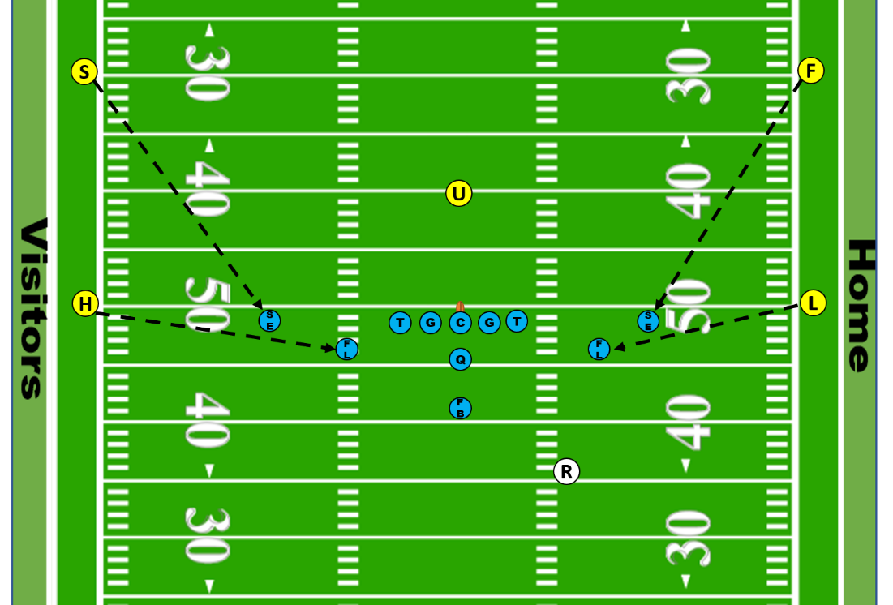

**1 Back, Pro** - An offense for run and pass plays like draw and screen passes. May use the flanker as a motion man. Pass blocking is normally used. Watch for ineligibles downfield (pass caught beyond neutral zone); pick plays by the split end or flanker and chop blocks.

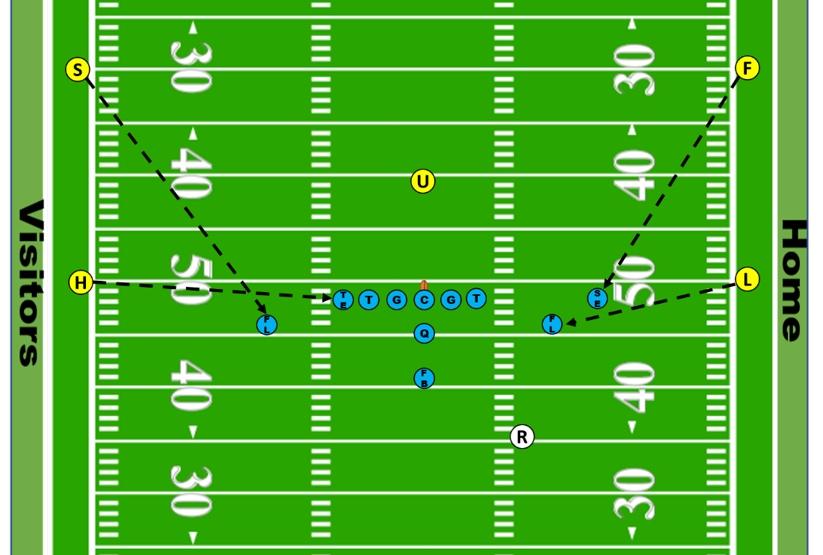

**2 Back, 3 Receiver Offset I** - An offense for pass plays like medium range and deep range passes. Pass blocking is used and the fullback normally blocks. The quarterback may shift into or out of the shotgun. Watch for blocking below the waist by the backs.

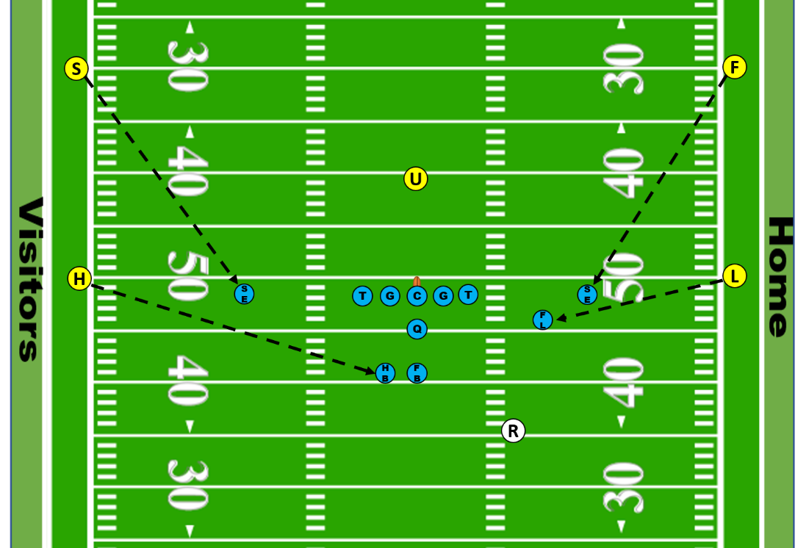

**2 Back, Pro** - An offense for run and pass plays like runs outside, screen passes and passes to the backs. May use the flanker as a motion man. One-on-one blocking is normally used. Watch for ineligibles downfield (pass caught beyond neutral zone); pick plays by the split end or flanker and chop blocks.

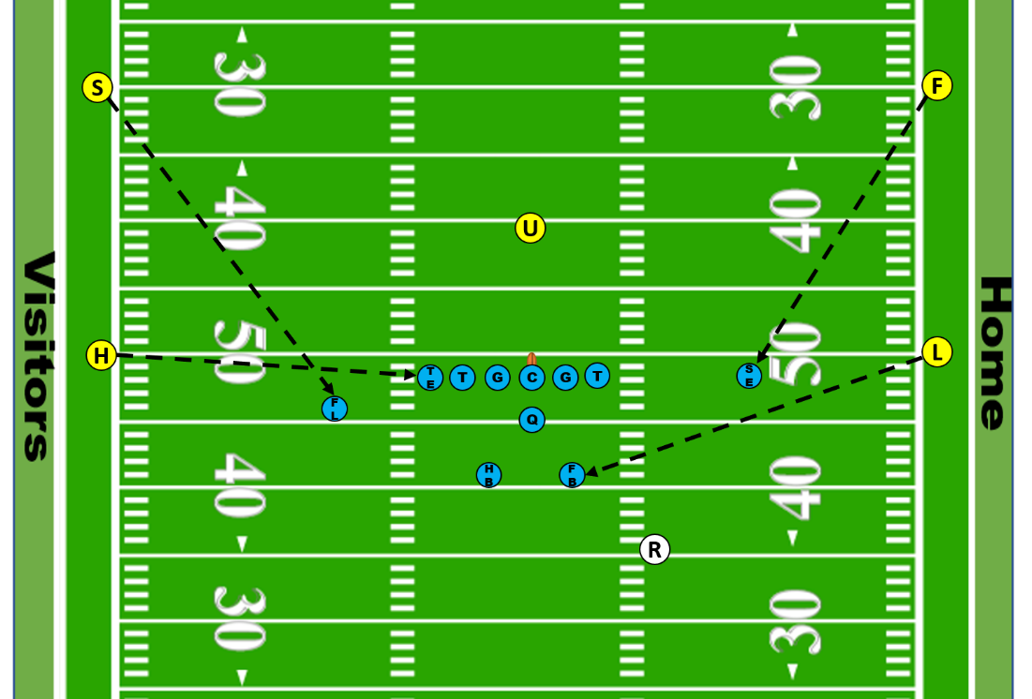

**Wing T** - An offense for run plays like a quarterback bootleg away from the motion man, fake handoff to motion man, wingback reverses, between the tackles or inside counter plays. Watch for crack back blocks by the wingbacks.

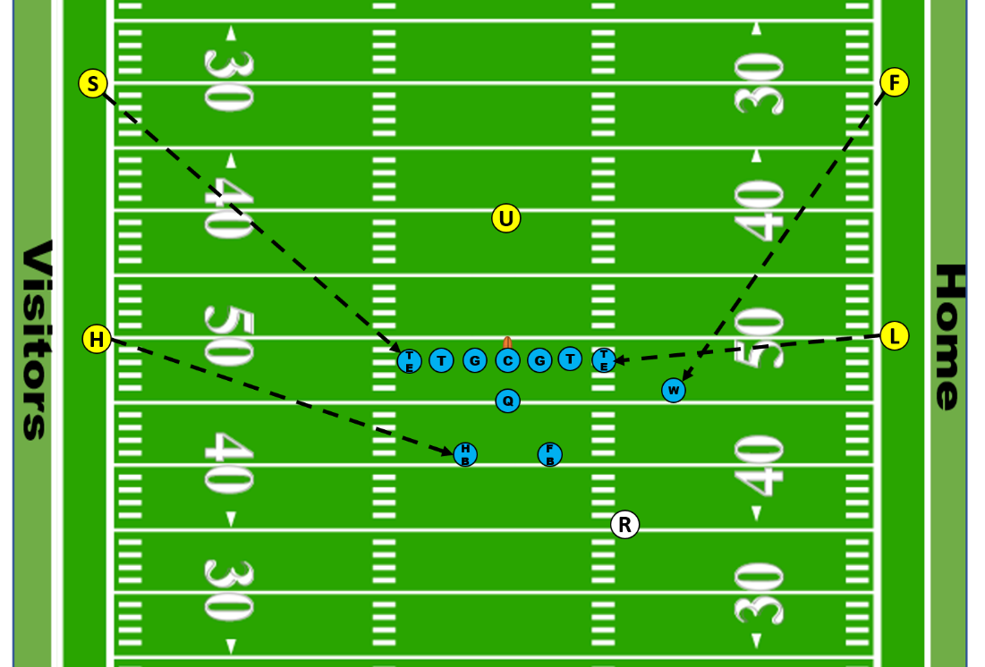

**Double Wing T** - An offense for pass and run plays like a quarterback bootleg away from the motion man, fake handoff to motion man, wingback reverses, between the tackles or inside counter plays. Straight blocking is normally used however the tight end and wingback frequently double team. Watch for crack back blocks by the wingbacks.

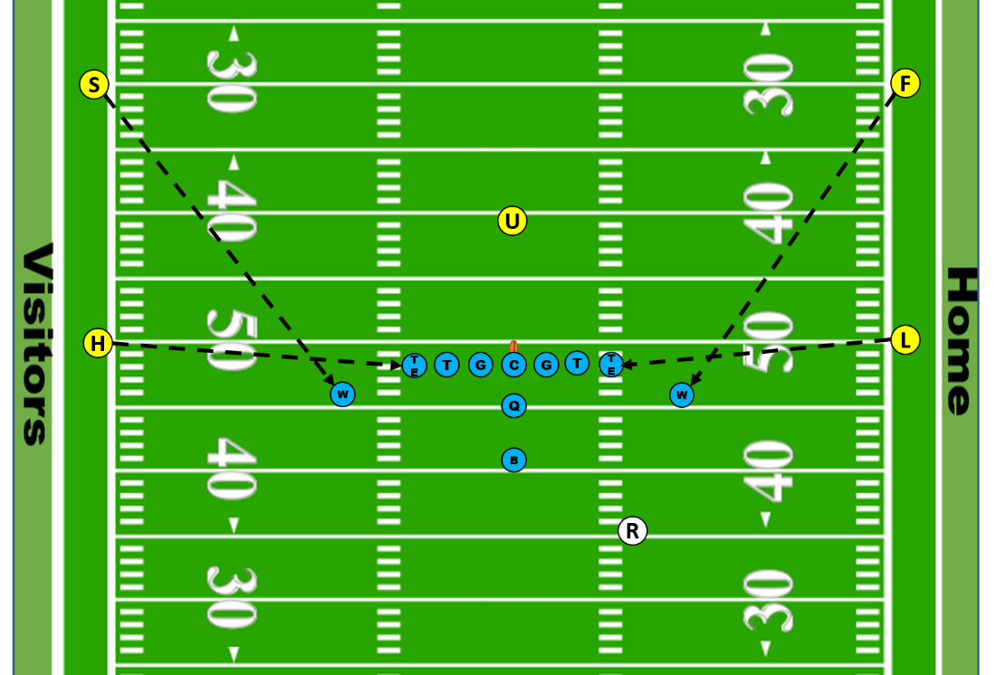

**I Formation** - An offense for pass plays like short, medium and deep passes; run plays like triple option and between the tackles; or tosses to the fullback or tailback. May use the flanker as a motion man. Trap as well as one-on-one blocking may be used.

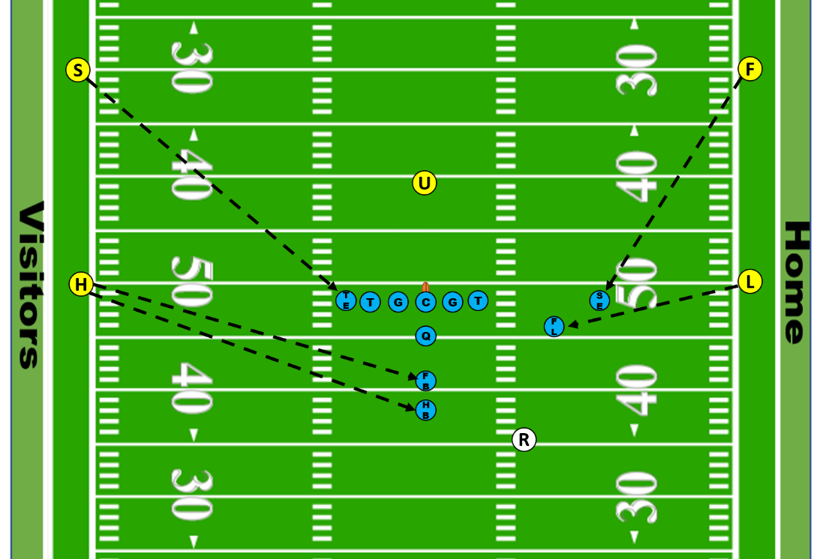

**Straight T** - An offense for run plays like trap, dive, inside handoff and sweep. Pulling guards, backs leading sweeps and trap blocks are used. Watch for illegal blocks on sweep and trap plays. One tight end may line up wide to spread the defense.

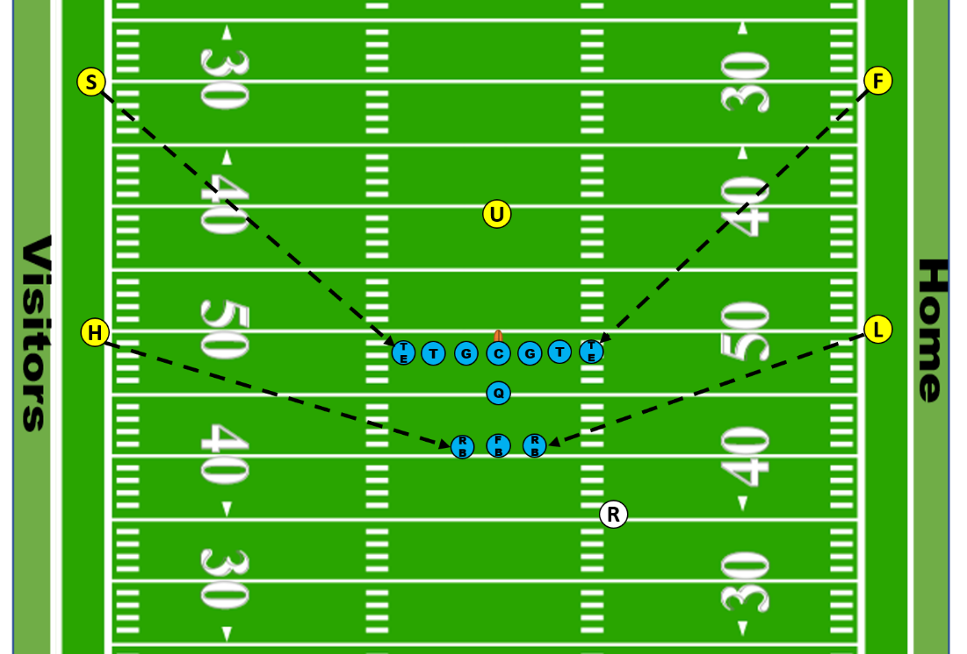

**Veer** - An offense for run plays like sweep and triple option, which may utilize the tight end or flanker as a motion man. These plays are often run to the weak side. Pulling guards and backs leading sweeps are used. The quarterback may pitch the ball to a back or keep the ball.

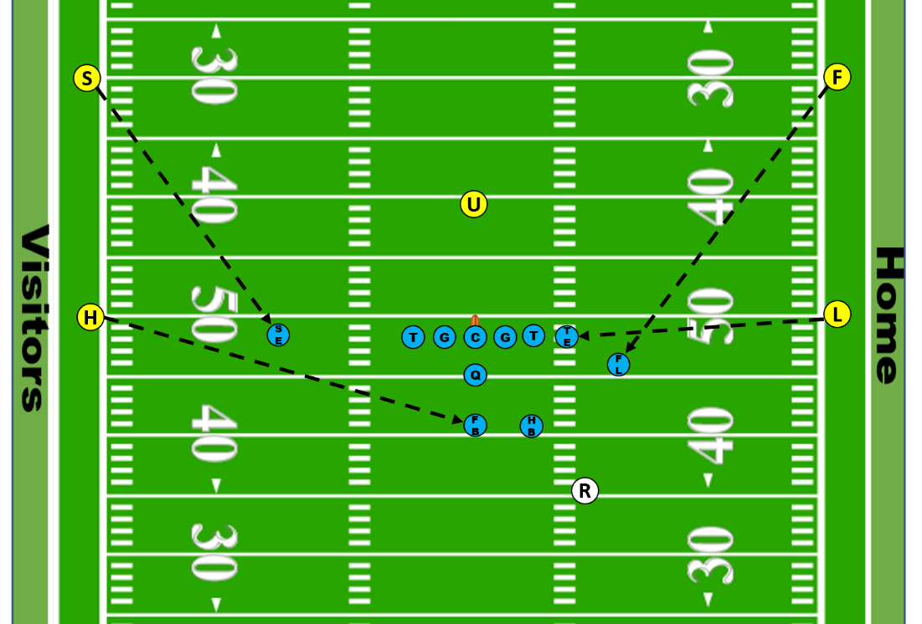

**Trips** - An offense for pass plays like medium range and deep range passes as well as passes to the back. Pass blocking is used. The back and/or tight end may run pass patterns or block. Watch for picks downfield by the flankers and/or split end. The quarterback may shift into or out of the shotgun. In a trips formation, 1 or 2 flankers may be stacked behind the split end who remains the widest receiver.

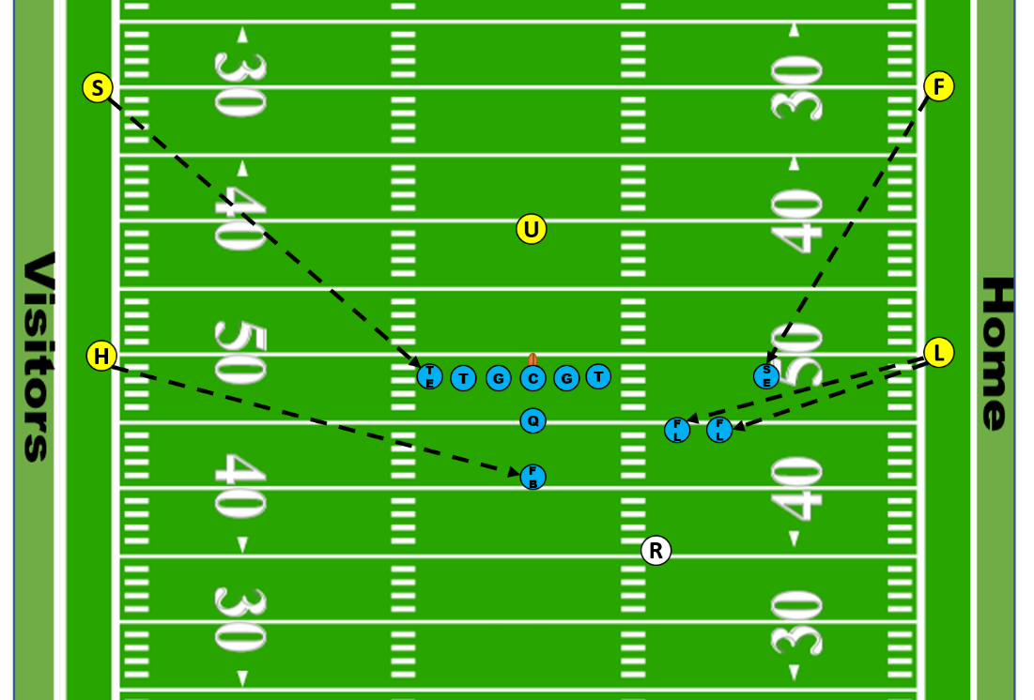

**Wishbone** - An offense for run plays like sweep and triple option. Pulling guards, backs leading sweeps and trap blocks are used. Watch for illegal blocks on sweep and trap plays. The tight ends normally block but may line up wide to spread the defense.

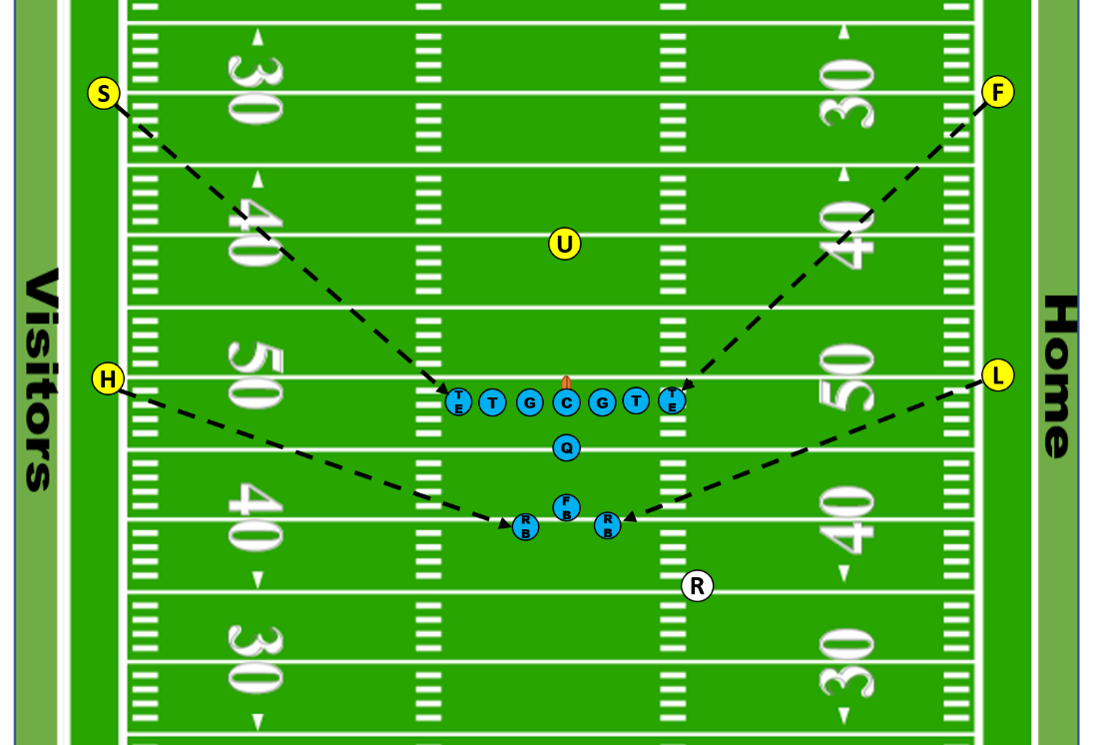

**PRE-GAME:**

**OFF THE FIELD DUTIES:**

• Meet with other officials at the stadium at least 1.5 hours for Varsity games and 45 minutes for sub-Varsity games before kickoff time.

• Conduct a thorough pre-game conference to prepare the crew mentally for the game. If the Referee is delayed for any reason, the senior official present should conduct the conference.

• Check your watch with the official who will keep the game clock. Review measurement, VHSL mercy rule and overtime procedures.

• Conduct equipment checks with all officials. Ensure that you have all needed equipment (i.e., flag, beanbag, whistle, game card, rubber band or other down indicator and timing device (Field and Side Judges in a 6-man crew).

• Leave the changing room with the other officials to be on the field at least 30 minutes before the scheduled start time.

**ON-FIELD DUTIES:**

All Officials:

• Inspect the facilities and playing surface as early as possible. Seek the cooperation of game management to rectify any faults to prevent delaying game start time.

• Inspect the playing field and the sidelines to ensure there are no hazards. If there is a hazard found, report it to the Referee immediately. Anything that is a hazard to any participant must be corrected before the contest can begin. The Referee should report any hazard to game administration and/or their state association.

• Obtain and record names and numbers of each captain on your game card.

Referee:

• Visit each team's head coach, with a designated official and establish the following:

* Confirm the game starting time and pregame event schedule.
* Have the head coach confirm his players are legally equipped and players’casts or braces requiring inspection.
* Determine if there are any unusual plays of which officiating crew should be aware.
* Ask the home team coach if there are any activities that might extend half time.
* Obtain each captain’s name and number, identify speaking captain and note on your game card.
* Approve clock operator if provided by home team.
* Conduct pre-game.

• Conduct an on-field pre-game conference to pass information from head coach meetings to all officials.

Umpire:

• Be alert for any illegal equipment.

• Check any casts, braces or equipment that is in question or if identified by the coach.

Linesman:

• Inspect chains and down marker equipment.

• Meet with chain-crew and review their responsibilities.

• Have a minimum of three chain-crewmembers (preferably four).

• Have chain-crewmembers wear vests, if possible.

• Check playing field on visiting team side from goal line to goal line between the numbers and to 5 yards beyond sideline for player safety issues.

• Spot check visiting team players’ equipment after chain crew.

Line Judge:

• You are responsible for positioning approved game balls to support ball rotation mechanic.

• Check playing field on home team side from goal line to goal line between the numbers and to 5 yards beyond sideline for safety issues.

• Spot check home team players’ equipment.

Side Judge:

• You are responsible for the official game clock on the field.

• Give instructions to clock operator.

• Examine the visiting team’s game balls provided. If they are acceptable, mark each ball and pass them to the officials responsible for ensuring proper ball rotation during play.

• Check playing field on visiting team side from end line to end line between the numbers and middle of the field as well as end line pylons, visiting side of endzone and uprights for safety issues.

• Spot check visiting team players’ equipment.

• Give instructions to visiting team ball boys.

Field Judge:

• You are responsible for timing the 25-second/40-second play clock; timeouts; and intermissions between scores and periods.

• Examine the home team’s game balls provided. If they are acceptable, mark each ball and pass them to the officials responsible for ensuring proper ball rotation during play.

• Check playing field on home team side from end line to end line between the numbers and middle of the field as well as end line pylons, home side of endzone and uprights plus crossbars for safety issues.

• Spot check home team players’ equipment.

• Give instructions to home team ball boys.

**COIN TOSS MECHANICS:**

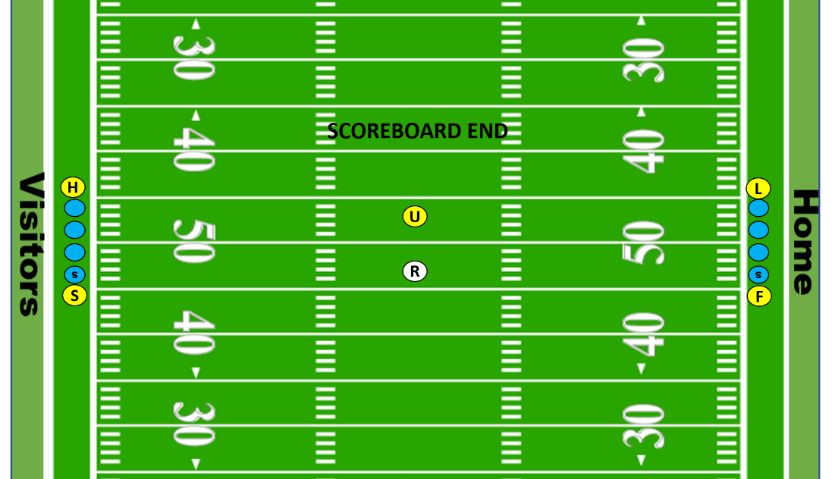

Referee:

• Enter the playing field, at the 50-yard line. After the coin flip, give the following options to the winning team's captain:

* Receive
* Defer their choice to the second half
* Defend the goal of their choice
* Kick

• The team's captain that did not win the coin toss has the option of choices that the winning captain did not select.

• Indicate the winning captain's choices to the press box side of the field.

Umpire:

• Enter the playing field, at the 50-yard line. Stay in the middle of the playing field and confirm the options given to the captains by the Referee. Note the options on your game card.

Linesman:

• Position on sideline at the 50-yard line, assist the Side Judge with positioning and briefing the captains from the visiting team at 5 minutes before game start time.

Line Judge:

• Position on sideline at the 50-yard line, assist the Field Judge with positioning and briefing the captains from the home team at 5 minutes before game start time.

Field Judge:

• Enter the playing field, at the 50-yard line, accompanied by the Captains for the home team. Stop, during the coin toss, at the top of the numbers, send the captains in, then return to the sideline once captains arrive in middle of the field.

Side Judge:

• Enter the playing field, at the 50-yard line, accompanied by the Captains for the visiting team. Stop, during the coin toss, at the top of the numbers, send the captains in, then return to the sideline once captains arrive in middle of the field.

All Officials:

• After the coin toss, move to your respective kickoff position.

**FREE KICK:**

**KICKOFF (REGULAR):**

All officials: Ensure both teams have 11 players legally on the field before Referee puts ball in play.

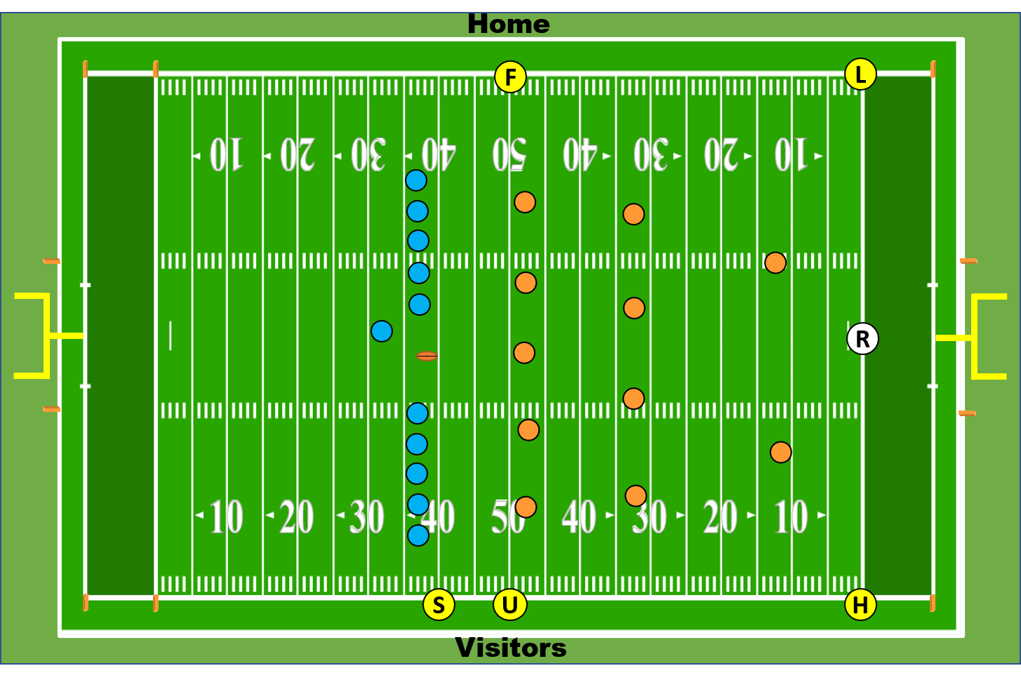

Referee:

• Count R players.

• Take a position on R's goal line.

• When ready to play, make eye contact with Line Judge, Linesman and Umpire; use hand signals to confirm that crew is in position and ready.

• When all are ready, point to the kicker and blow your whistle and give the "ready-for-play" signal. At this time the 25 second clock starts.

• When R first touches the ball legally, give the "start clock" signal.

• If the ball is kicked in your zone, pick up the runner, trail the play cautiously and cleanup behind the ball.

• You have secondary responsibility for making the call whether the kicked ball breaks the goal line plane. If the kick is deep, get into a position for a "straight down the line" view. As soon as the ball breaks the goal line plane, blow the play dead.

• Rule on "momentum" inside the five-yard line (Rule 8-5-2a Exception).

• If kick is out-of-bounds, determine with Linesman or Line Judge if last touched by “R” or “K”.

• Penalty Responsibilities:

* + Free kick infraction (Rule 6-1-3b, 4, 11)
  + Free kick out of bounds (Rule 6-1-8)
  + Illegal blocking technique (Rules 9-2-1a and 9-2-3a)
  + Clipping (Rule 9-3-5)

Umpire:

• Clear your sideline before the kickoff (jog the Head Lineman’s sideline after a score).

• Initial position is on the receiving team’s restraining line with right foot on the 50-yard line and left foot in the neutral zone

• Count the K players

• Signal when you are ready for the kickoff until acknowledged by the Side Judge.

• You are responsible for observing for a pop-up kick.

• Wind clock if legally touched in your area.

• After the kick is away, move cautiously in towards the center of the field, officiating between the hashes inside out

• Watch initial blocks

• Do not drift back into R's end of the field. Officiate up field from the ball, keeping an eye on the ball for long runbacks that cross back into your zone.

• Penalty Responsibilities:

* Free kick infraction (Rule 6-1-2, 3b, 4, 11)
* Free kick out of bounds (Rule 6-1-9)
* Encroachment (Rule 6-1-3a)
* Illegal blocking technique (Rules 6-5-1, 9-2-1a and 9-2-3a)
* Illegal use of hands (Rules 9-2-1b, c, 9-2-3b, c, d)

Side Judge:

• Initial position is on the kicking team’s restraining line.

• Run out to the kicker with the ball and provide instruction to wait for R’s whistle. Be sure to check legality of the ball and tee

• Receive the ready signal from the Field Judge & Umpire, and after you are ready, signal to the R that everyone upfront is ready.

• Run to the sideline on Umpire’s side. You have responsibility for the kicking team’s restraining line. Position is left foot on the 40-yard line and right foot in the neutral zone

• Be alert for onside kick and first touching

• Along with the Field Judge, you have goal line responsibility on long runbacks.

• You are responsible for blocks against the kicker and holder

• Penalty Responsibilities:

* + Free kick infraction (Rule 6-1-2, 3b, 4, 11)
  + Free kick out of bounds (Rule 6-1-9)
  + Encroachment (Rule 6-1-3a)
  + Kick Catching Interference (Rule 6-5-6)
  + Illegal blocking technique (Rules 6-5-1, 9-2-1a and 9-2-3a)
  + Illegal use of hands (Rules 9-2-1c, 9-2-3a, c)

Linesman:

• Count the R players

• Take a position on R's goal line.

• Assist the Referee with "muff or "fumble" calls near the goal line.

• You have responsibility for the pylon on your side.

• Signal when you are ready for the kickoff until the Referee acknowledges you.

• If the kick goes out-of-bounds on your sideline, use your beanbag (last touched by R) or flag (untouched or last touched by K).

• If the kick comes to your side, give the "start clock" signal when R legally touches the ball.

• Trail the runner cautiously up the field so long as he remains between the far inbounds mark and your sideline.

• Remain alert for reverses and fumbles.

• Observe actions of the other players around the ball carrier.

• You have primary responsibility for making the call whether the kicked ball breaks the goal line plane in your zone. If the kick is deep, get into a position for a "straight down the line" view. As soon as the ball breaks the goal line plane, blow the play dead.

• Penalty Responsibilities:

* + Kick Catching Interference (Rule 6-5-6)
  + Free kick out of bounds (Rule 6-1-9)
  + Illegal blocking technique (Rules 6-5-1, 9-2-1a and 9-2-3a)
  + Illegal use of hands/holding (Rules 9-2-1b, c, 9-2-3b, c, d)

Line Judge:

• Take a position on R's goal line.

• Count the R players.

• Signal when you are ready for the kickoff until acknowledged by the Referee.

• Assist the Referee with "muff or "fumble" calls near the goal line.

• You have responsibility for the pylon on your side.

• If the kick comes to your side, give the "start clock" signal when R legally touches the ball.

• Trail the runner cautiously up field so long as he remains between the far inbounds mark and your sideline.

• Remain alert for reverses and fumbles.

• Observe the action of other players around the ball carrier.

• If the kick goes out-of-bounds on your sideline, use your beanbag (last touched by R) or flag (untouched or last touched by K).

• You have primary responsibility for making the call whether the kicked ball breaks the goal line plane in your zone. If the kick is deep, get into a position for a "straight down the line" view. As soon as the ball breaks the goal line plane, blow the play dead.

• Penalty Responsibilities:

* + Free kick out of bounds (Rule 6-1-9)
  + Kick Catching Interference (Rule 6-5-6)
  + Illegal blocking technique (Rules 6-5-1, 9-2-1a and 9-2-3a)
  + Illegal use of hands/holding (Rules 9-2-1b, c, 9-2-3b, c, d)

Field Judge:

• You have responsibility for the receiving team’s restraining line. Position is left foot on the 50-yard line and right foot in the neutral zone

• Count K players.

• Clear your sideline before the kickoff (jog the Line Judge’s sideline after a score).

• Signal when you are ready for the kickoff until acknowledged by the Side Judge.

• You are responsible for observing for a pop up kick.

• After the kick, watch for first touching and for the ball that does not cross R’s restraining line.

• Watch initial blocks.

• Do not drift back into R's end of the field. Officiate up the field from the ball, keeping an eye on the ball for long runbacks that cross back into your zone.

* Along with the Side Judge, you have K’s goal line responsibility on long runbacks.

• Penalty Responsibilities:

* + Free kick infraction (Rule 6-1-2, 3b, 4, 11)
  + Kick Catching Interference (Rule 6-5-6)
  + Free kick out of bounds (Rule 6-1-9)
  + Encroachment (Rule 6-1-3a)
  + Illegal blocking technique (Rules 6-5-1, 9-2-1a and 9-2-3a)
  + Illegal use of hands (Rules 9-2-1b, c, 9-2-3b, c, d)
* Delay of game (Rules 3-6-2, 3-6-5)

**KICKOFF (ONSIDE):**

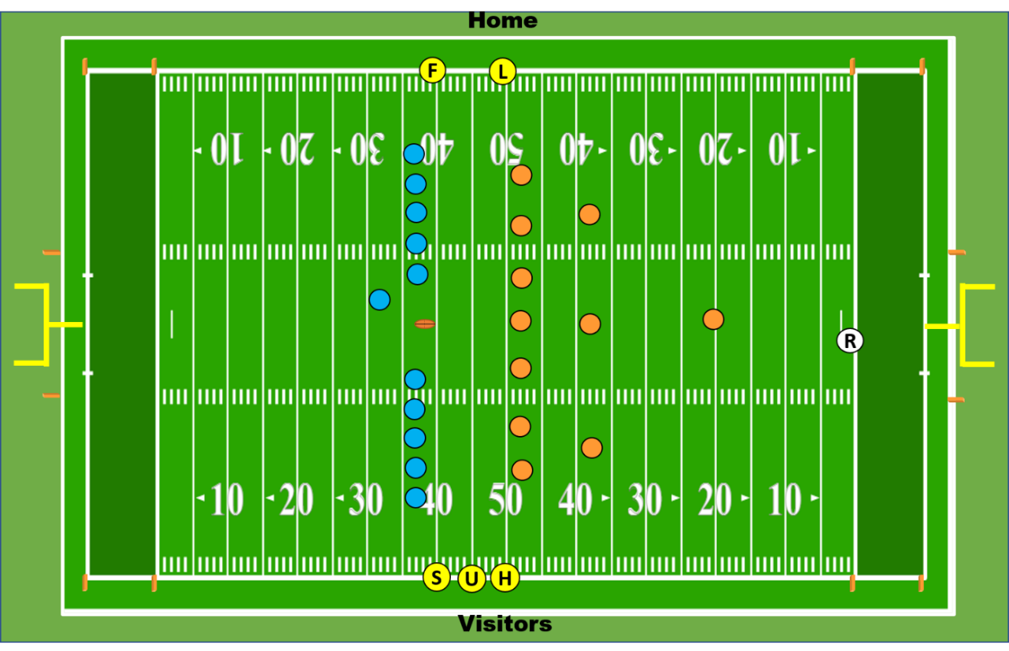

Referee:

• Count R players.

• Take a position on R’s goal line

• When ready to play, make eye contact with Side Judge to confirm that each crewmember is in position and ready.

• When all are ready, point to the kicker and blow your whistle and give the "ready-for-play" signal. At this time the 25-second clock starts.

• When R first touches the ball legally, give the "start clock" signal.

• If the ball is kicked in your zone, pick up the runner until he advances into another official’s zone (approximately the 30-yard line), then release to the covering official.

• After the runner in released, trail the play cautiously and cleanup behind the ball.

• You have sole responsibility for making the call whether the kicked ball breaks the goal line plane. If the kick is deep, retreat to the goal line to get a "straight down the line" view. As soon as the ball breaks the goal line plane, blow the play dead.

• Rule on "momentum" inside the five-yard line (Rule 8-5-2a Exception).

• If the kick is out-of-bounds, determine with covering official if last touched by “R” or “K”.

• Penalty Responsibilities:

* + Free kick infraction (Rule 6-1-3b, 4, 11)
  + Kick Catching Interference (Rule 6-5-6)
  + Free kick out of bounds (Rule 6-1-9)
  + Free kick out of bounds (Rule 6-1-9)
  + Illegal blocking technique (Rules 6-5-1, 9-2-1a and 9-2-3a)
  + Clipping (Rule 9-3-5)

Side Judge:

• Count K players.

• You have the ball. Ask the Kicker if he intends to attempt an Onside Kick. If so, provide a prearranged signal to the rest of the officiating crew to alert them. Hand the ball to the kicker and instruct him not to kick the ball until the Referee sounds his whistle, then run off to the sideline and take your position on the kicker’s restraining line (normally 40-yard line).

• Signal with raised hand when the crew is ready for the kickoff until acknowledged by the Referee.

• You have primary responsibility for the kicking team’s restraining line and initial blocks by K.

• If kick goes deep, keep a cushion on the ball should there be a run back. You have responsibility for the goal line on any long returns.

• Penalty Responsibilities:

* + Free kick infraction (Rule 6-1-2, 3b, 4, 11)
  + Encroachment (Rule 6-1-3a)
  + Kick Catching Interference (Rule 6-5-6)
  + Free kick out of bounds (Rule 6-1-9)
  + Illegal blocking technique (Rules 6-5-1, 9-2-1a and 9-2-3a)
  + Illegal use of hands (Rules 9-2-1c , 9-2-3a, c)

Linesman:

• Count the R players

• You have responsibility for the receiving team's restraining line.

• Signal when you are ready for the kickoff until acknowledged by the Side Judge and have beanbag in hand.

• If the kick comes to your side, give the "start clock" signal if touched by R, watch for first touching and for the ball that does not cross R’s restraining line.

• Observe the action of players around the ball.

• If the kick goes out-of-bounds on your sideline before R’s restraining line, use your beanbag (last touched by R) or flag (untouched or last touched by K).

* If kick goes deep, drift back into R's end of the field to cover ball and pick up runner. Officiate up-field from the ball and pick up runner near the 30-yard line, keeping an eye on the ball for runbacks that cross back into your zone.
* Once the ball is recovered kill the clock and blow your whistle to signal the play is dead. Crash in when team in possession is in doubt

• Penalty Responsibilities:

* + Free kick infraction (Rule 6-1-2, 3b, 4, 11)
  + Encroachment (Rule 6-1-3a)
  + Free kick out of bounds (Rule 6-1-9)
  + Illegal blocking technique (Rules 6-5-1, 9-2-1a and 9-2-3a)
  + Illegal use of hands/holding (Rules 9-2-1b, c, 9-2-3b, c, d)

Line Judge:

• Count the R players.

• You have responsibility for the receiving team's restraining line.

• Signal when you are ready for the kickoff until acknowledged by the Side Judge and have beanbag in hand.

• If the kick comes to your side, give the "start clock" signal if touched by R, watch for first touching and for the ball that does not cross R’s restraining line.

• Observe the action of players around the ball.

• If the kick goes out-of-bounds on your sideline before R’s restraining line, use your beanbag (last touched by R) or flag (untouched or last touched by K).

• If kick goes deep, drift back into R's end of the field to cover ball and pick up runner. Officiate up-field from the ball and pick up runner near the 30-yard line, keeping an eye on the ball for runbacks that cross back into your zone.

• Once the ball is recovered kill the clock and blow your whistle to signal the play is dead. Crash in when team in possession is in doubt.

• Penalty Responsibilities:

* + Encroachment (Rule 6-1-3a)
  + Free kick infraction (Rule 6-1-2, 3b, 4, 11)
  + Free kick out of bounds (Rule 6-1-9)
  + Illegal blocking technique (Rules 6-5-1, 9-2-1a and 9-2-3a)
  + Illegal use of hands/holding (Rules 9-2-1b, c, 9-2-3b, c, d)

Field Judge:

• Count K players.

• Clear your sideline before the kickoff (jog the Line Judge’s sideline after a score).

• Signal when you are ready for the kickoff until acknowledged by the Side Judge and have beanbag in hand.

• You have primary responsibility for the kicking team’s restraining line and initial blocks by K.

• If kick goes deep, keep a cushion on the ball should there be a run back. You have responsibility for the goal line on any long returns.

• Penalty Responsibilities:

* + Delay of game (Rules 3-6-2, 3-6-5)
  + Free kick infraction (Rule 6-1-2, 3b, 4, 11)
  + Kick Catching Interference (Rule 6-5-6)
  + Free kick out of bounds (Rule 6-1-9)
  + Encroachment (Rule 6-1-3a)
  + Illegal blocking technique (Rules 6-5-1, 9-2-1a and 9-2-3a)
  + Illegal use of hands (Rules 9-2-1b, c, 9-2-3b, c, d)

Umpire:

• Count K players.

• Initial position is on the 45-yard line, bean bag in hand.

• Signal when you are ready for the kickoff until acknowledged by the Side Judge.

• You have responsibility for the neutral zone and your primary focus is blocks by K before the ball is touched or crosses R’s restraining line.

• After the kick, watch for first touching and for the ball that does not cross R’s restraining line.

• Once the ball is recovered kill the clock.

• Penalty Responsibilities:

* + Free kick infraction (Rule 6-1-2, 3b, 4, 11)
  + Encroachment (Rule 6-1-3a)
  + Free kick out of bounds (Rule 6-1-9)
  + Illegal blocking technique (Rules 6-5-1, 9-2-1a and9-2-3a)
  + Illegal use of hands (Rules 9-2-1b, c, 9-2-3b, c, d)

**SCRIMMAGE PLAYS:**

**BEFORE THE SNAP:**

Referee:

• Count A Players.

• Make sure the other officials and the chain crew is in position before giving the ready-for-play signal and whistle.

• Check your down marker. Then make eye contact with Umpire, Linesman and Line Judge and confirm down, clock status and A player count, use hand signals.

• Double-check clock status with Umpire, then check the clock.

• Line up on the Quarterback’s throwing-arm side about 15 yards behind line of scrimmage, but at least five to seven yards behind the deepest offensive back.

• Be sure that you have a good view of the Center, ball and Quarterback’s hands. Be sure to position to have the Tight End and opposite side Tackle in your field of view and be able to determine if/when Quarterback is beyond the lateral boundary of the free blocking zone.

• Penalty Responsibilities:

* + Illegal motion (Rules 7-2-6, 7)
  + Illegal shift (Rules 7-2-6, 7)
  + Illegal act by snapper (Rules 7-1-2, 3, 7-2-4)
  + False start (Rules 7-1-7)
  + Illegal formation or procedure at the snap (7-2-1, 2, 3)

Umpire:

• Stay over the ball until the Referee releases you. Back out after released. Do not turn your back to the ball.

• Position yourself at least ten-yards deep on B's side of the line when the defensive team is in the huddle, moving forward and right or left to a position eight to ten-yards deep behind the defensive line once the offense comes over the ball.

• Vary your position with each play depending upon the anticipated plays, so that the offense does not develop the habit of using you as an extra blocker. As a general rule, position yourself away from the tight end and favor the short side of the field. You may want to line up slightly deeper on passing downs.

• Verbally confirm down, distance and clock status with the Referee prior to each snap.

• Verify that there are at least five offensive linemen numbered 50 - 79 (exception: Scrimmage kick formations).

• Locate the tight end and the five players inside who are ineligible. One of your primary responsibilities is knowing who is ineligible on all scrimmage plays.

• Check for equipment that became illegal through play.

• Be alert for false starts by the offensive lineman that have become set.

• Use an elastic band on one hand to note lateral placement of the ball between hashmarks. Use a band on the other hand to keep track of the down.

• Observe the center's handling of the ball prior to the snap.

• Do not allow the defense to interfere with the Quarterback's signal calling.

• At the snap, concentrate on the five interior offensive linemen and their actions, particularly the guards and snapper, along with the actions of their defensive counterparts.

• Penalty Responsibilities:

* + Illegal act by snapper (Rules 7-1-2, 3, 7-2-4)
  + False start (Rules 7-1-7)
  + Illegal formation or procedure at the snap (7-2-1, 2, 3)
  + Illegal use of hands/holding (Rules 9-2-1b, c, 9-2-3b, c, d)

Linesman:

• Count the A players

• Do not signal the chain crew to move until you receive a signal from the line Judge and confirmation from the Referee.

• Be sure not to turn your back on the field while attending to the chains unless you have advised the Side Judge to cover your area beforehand.

• Establish and maintain control of your sideline area.

• Line up on the sideline. Stay wide. Your feet should straddle the neutral zone.

• Make eye contact with the Referee and Line Judge. Verify down and distance with the box man, then signal to the other crewmembers. Signal "double stakes" if the yardage to the line-to-gain exceeds 10-yards.

• Identify eligible receivers on your side and in the backfield.

• Do not coach the wide receivers as to where they "should be". Instead, simply advise them either:

* "I have you on the line".
* "I have you in the backfield".

• Signal "man off the line” if he is in the backfield to indicate the position of widest man on your side and use fingers to indicate number of eligible receivers in backfield outside the tackles.

• You have the responsibility for the man in motion coming to you.

• Penalty Responsibilities:

* + Illegal substitution (Rule 3-7)
  + Illegal participation (Rule 9-6)
  + False start (Rules 7-1-7)
  + Encroachment (Rule 6-1-4)
  + Illegal formation or procedure at the snap (7-2-1, 2, 3)
  + Sideline warning/interference (Rule 9-8-1k, 3)
  + Illegal motion (Rule 7-2-7)
  + Failure to properly wear required equipment (Rule 3-6-2d)

Line Judge:

• Count the A players.

• Establish and maintain control of your sideline area.

• Line up on the sideline. Stay wide. Your feet should straddle the neutral zone.

• Make eye contact with the Referee and Linesman. Verify down and distance with a signal to the other crewmembers. Then visually confirm the down box indication. Signal "double stakes" if the yardage to the line-to-gain exceeds 10-yards.

• Identify the eligible receivers on your side and in the backfield.

• Do not coach wide receivers as to where they "should be. Instead, simply advise them either:

* "I have you on the line".
* "I have you in the backfield".

• Signal "man off" if on your side of the line he is in the backfield to indicate the position of the widest man and use fingers to indicate number of eligible receivers in backfield outside the tackles.

• You have responsibility for the man in motion coming to you, even if he reverses direction.

• Penalty Responsibilities:

* + Illegal substitution (Rule 3-7)
  + Illegal participation (Rule 9-6)
  + False start (Rules 7-1-7)
  + Encroachment (Rule 6-1-4)
  + Illegal formation or procedure at the snap (7-2-1, 2, 3)
  + Sideline warning/interference (Rule 9-8-1k, 3)
  + Illegal motion (Rule 7-2-7)
  + Failure to properly wear required equipment (Rule 3-6-2d)

Field Judge:

• Count B players and confirm count with Side Judge.

• Line up at least 20-yards deep from the line of scrimmage, starting on the sideline. Make sure you are deeper than the deepest defensive back. Position on goal line when ball spotted inside B’s 25-yard line. Adjust position based on game situations.

• Identify the eligible receivers on your side and in the backfield. Your primary responsibility is the widest man on your side of the field.

• Verify down and distance with a signal to the other crewmembers.

• You are the co-guardian of the end line.

• Penalty Responsibilities:

* + Illegal substitution (Rule 3-7)
  + Illegal participation (Rule 9-6)
  + Delay of game (Rule 3-6-2)

Side Judge:

• Count B players and confirm count with Field Judge.

• Line up at least 20-yards deep from the ball, starting on the sideline. Make sure you are deeper than the deepest defensive back. Position on goal line when ball spotted inside B’s 25-yard line. Adjust position based on game situations.

• Identify the eligible receivers on your side and in the backfield. Your primary responsibility is the widest man on your side of the field.

• Verify down and distance with a signal to the other crewmembers.

• You are the co-guardian of the end line.

Penalty Responsibilities:

* Illegal substitution (Rule 3-7)
* Illegal participation (Rule 9-6)
* Delay of game (Rule 3-6-2)

**RUNNING PLAYS:**



Referee:

• Key the tackle on the opposite side for run/pass block clue.

• Take the ball carrier and action around him until he crosses the line of scrimmage.

• Remain well behind the action.

• Be alert for reverses.

• Go into the side zone on option runs or passes.

• Assist Linesman or Line Judge to rule on the out-of-bounds spot behind the neutral zone.

• Rule on action on the Quarterback

• Penalty Responsibilities:

* + Illegal blocking technique by A (Rules 9-2-1a and 9-2-3a)
  + Illegal use of hands/holding (Rules 9-2-1c and 9-2-3b, c, d)
  + Personal fouls (Rule 9-4-2)

Umpire:

• Officiate from the "inside out".

• Use the center and guards as keys for run or pass.

• Know where the line of scrimmage is at all times (glance at the down box, if necessary).

• You have responsibility for assisting wings on running plays up the middle - only blow whistle to prevent injury but make sure you see the ball first.

• As the running play develops, read and react. If inside run, quickstep laterally away from the hole keeping your eyes on the action at all times. Watch out for the tight end coming across. If outside run, shift your eyes from the original line play to the action around the runner. Observe the fringe area surrounding the runner. Drift toward developing action outside, but do not pursue too aggressively (you have outside support from both wing officials and the Referee). Be alert for crack back blocks and clipping.

• Unless the Referee instructs otherwise, the Umpire is responsible for spotting the ball after every play. Communicate with the wing officials so they do not move until you have their spot. Before releasing the wing official from which you are taking the spot, turn and face him. Then confirm with him either verbally or through hand signals - that you have his spot. Before backing out from spotting the ball when team A is at the line, check to ensure officials, chains and down box are in position.

• In getting the ball from the wing officials, be prepared to step into either team's backfield to receive the relay. Unless the Referee instructs otherwise, you are responsible for handling the ball and stepping off yardage on penalty enforcement.

• As a general rule, do not cross the inbounds mark. The Referee and wing officials can handle action in the side-zones. If the ball goes out-of-bounds, take the relay from the wing officials, or Referee, at the inbounds mark.

• Penalty Responsibilities:

* + Illegal blocking technique by A (Rules 9-2-1a and 9-2-3a)
  + Illegal use of hands/holding (Rules 9-2-1c and 9-2-3b, c, d)
  + Illegal procedure (Rule 7-2-1)
  + Personal fouls (Rule 9-4-2)
  + Helping the runner (Rule 9-1)

Linesman:

• Count the A players.

• Do not blow your whistle on runs in the middle of the field until you actually see the ball down in player possession.

• On runs toward you, keep all action inside of you. Step into the offensive backfield if necessary, in order to observe the play. If the ball carrier or ball goes out-of-bounds on your sideline, your first responsibility is to mark the out-of-bounds spot. Stay with the spot and let another official retrieve the ball. Continue to monitor player action out-of-bounds.

• Mark progress quickly and hold the spot until the Umpire spots the ball or the Referee or Line Judge releases you.

• You must see and rule on whether blocks are legal outside the tackle box to your sideline.

• Read run or pass from the near side tackle.

• Closely observe contact with eligible receivers by B.

• Be alert for reverses. Keep all action inside of and in front of you. Watch for action not related to football away from the ball.

• On pitch/option plays down the line, take the pitchman all the way. Take the loose ball in case of a fumble.

• Be prepared to assist the Referee to rule on a forward pass or fumble if the ball becomes loose during the run.

• Penalty Responsibilities:

* + Holding (Rules 9-2-1c and 9-2-3d)
  + Illegal blocking technique (Rules 9-2-1a and 9-2-3a)
  + Forward pass interference (Rule 7-5-10)
  + Personal fouls (Rule 9-4-2)
  + Clipping (Rule 9-5-3)

Line Judge:

• Count the A players.

• Do not blow your whistle on runs in the middle of the field until you actually see the ball down in player possession.

• Mark progress quickly and hold the spot until the Umpire spots the ball.

• You must see and rule on whether blocks outside the tackle box to your sideline are legal.

• Read run or pass from the near side tackle.

• Closely observe contact with eligible receivers by B.

• On runs toward you keep all action inside of you. Step into the offensive backfield, if necessary, in order to observe the play. If the ball carrier or the ball goes out-of-bounds on your sideline, your first responsibility is to mark the out-of-bounds spot. Stay with the spot and let another official retrieve the ball. Continue to monitor player action out-of-bounds.

• Be alert for reverses. Keep all action inside of you. Watch for extracurricular action away from the ball.

• On pitch/option plays down the line, take the pitchman all the way. Take the loose ball in case of a fumble.

• Be prepared to assist the Referee to rule on a forward pass or fumble if the ball becomes loose during the run.

• You are in the best position to note whether or not the runner has clearly reached the line-to-gain. If so, notify the referee and stop the clock. If close, notify the Referee immediately with a verbal signal: "Take a look, take a look". Do not give the first down signal.

• Penalty Responsibilities:

* + Holding (Rules 9-2-1c and 9-2-3d)
  + Illegal blocking technique (Rules 9-2-1a and 9-2-3a)
  + Forward pass interference (Rule 7-5-10)
  + Personal fouls (Rule 9-4-2)
  + Clipping (Rule 9-5-3)

Field Judge:

• At the snap, focus on actions on/by your key.

• On running plays downfield, assume responsibility for action in front of the runner.

• If the runner goes out-of-bounds follow the action out-of-bounds unless the pass or run is deep enough that the approaching wing official does not go to the spot before you do. In that case, note or beanbag the out-of-bounds spot and let the wing official know the yard line while continuing with the action into the side-zone.

• Do not get caught coming up on an action pass that appears to be a run but turns into a pass.

• Assist the Umpire with the ball exchange on wet or muddy fields.

• You are the co-guardian of the end line.

• Do not blow your whistle on runs in the middle of the field until you actually see the ball down in player possession.

• Penalty Responsibilities:

* + Holding (Rules 9-2-1c and 9-2-3d)
  + Illegal blocking technique (Rules 9-2-1a and 9-2-3a)
  + Forward pass interference (Rule 7-5-10)
  + Personal fouls (Rule 9-4-2)

Side Judge:

• At the snap, focus on actions on/by your key.

• On running plays downfield, assume responsibility for action in front of the runner.

• If the runner goes out-of-bounds follow the action out-of-bounds unless the pass or run is deep enough that the approaching wing official does not go to the spot before you do. In that case, note or beanbag the out-of-bounds spot and let the wing official know the yard line while continuing with the action into the side-zone.

• Do not get caught coming up on an action pass that appears to be a run but turns into a pass.

• Assist the Umpire with the ball exchange on wet or muddy fields.

• You are the co-guardian of the end line.

• Do not blow your whistle on runs in the middle of the field until you actually see the ball down in player possession.

• Penalty Responsibilities:

* + Holding (Rules 9-2-1c and 9-2-3d)
  + Illegal blocking technique (Rules 9-2-1a and 9-2-3a)
  + Forward pass interference (Rule 7-5-10)
  + Personal fouls (Rule 9-4-2)

**PASSING PLAYS:**

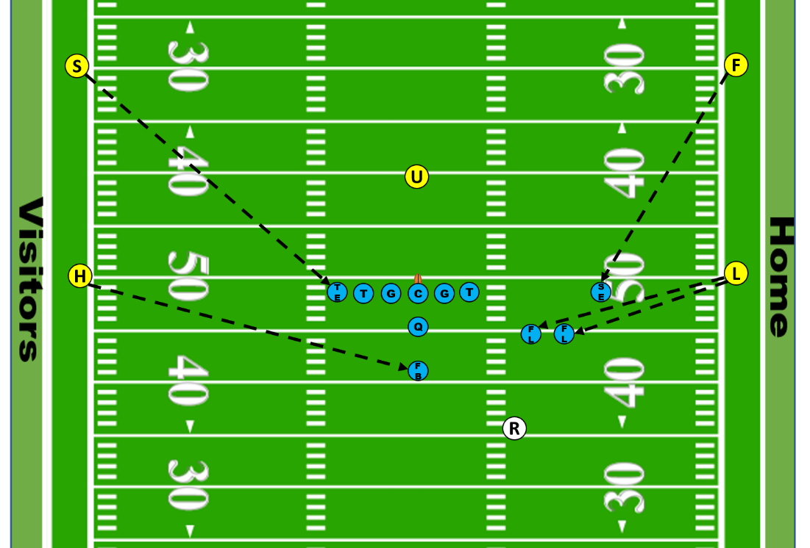

Referee:

• Key the tackle on the opposite side for run/pass block clue.

• Observe all blocks behind the neutral zone.

• You are the sole guardian of the passer. Position to the throwing arm side of the quarterback. Remain wider and deeper than the passer as the play develops. Once the ball is released, continue to observe the passer, not the flight of the ball.

• Verbally alert the pass rushers when the ball is released.

• Rule on whether the pass is forward or backward. Be alert for shovel pass vs. legal forward handing.

• Rule on whether the loose ball is a pass or fumble.

• If the passer moves forward before passing observe the position of his feet to determine if his feet were beyond the neutral zone when the ball was released.

• You have sole responsibility for intentional grounding.

• Penalty Responsibilities:

* + Holding (Rules 9-2-1c and 9-2-3d)
  + Roughing the passer (Rule 9-4-3)
  + Intentional grounding (Rule 77-5-2d, e and f)
  + Illegal pass (Rule 7-5-2a, b and c)

Umpire:

• You must know the ineligible receivers on every play.

• You must know where the line of scrimmage is as each play develops.

• Watch the initial line charge, being alert for holding and illegal blocks.

• As the pass play develops, drift toward the line of scrimmage.

• Use your beanbag, if necessary, to indicate the line.

• Observe the action of the players in and just behind the neutral zone.

• Assist the Referee in making the call whether the passer's feet were beyond the neutral zone.

• You must be able to rule on whether the pass touched anything before caught.

• Penalty Responsibilities:

* + Illegal use of hands/holding (Rules 9-2-1c and 9-2-3d)
  + Illegal blocking (Rules 9-3-2, 9-3-5 and 9-3-6)
  + Ineligible receivers illegally downfield (Rule 7-5-12)
  + Illegal forward pass (Rule 7-5-2a, b, and c)

Linesman:

• Count the A players.

• Read pass or run from the near side tackle.

• Do not be too quick to release downfield on a pass play. The Side Judge has deep coverage. Initial release should be only five to seven-yards downfield in any case.

• Be alert to assist Referee to rule on whether a pass was forward or backward.

• Develop and practice a clear and consistent understanding of what is and what is not pass interference.

• Your first responsibility on any completed pass is to hold or mark the spot once the play ends.

• On long passes downfield beyond the line to gain, communicate with the Referee immediately on the position of the ball and clock status.

• Remember that pass interference restrictions begin for the Offense at the snap; Defense when the ball leaves the passer's hand.

• Penalty Responsibilities:

* + Illegal use of hands (Rule 9-2-3b and d)
  + Offensive pass interference (Rule 7-5-10)
  + Defensive pass interference (Rule 7-5-10)

Line Judge:

• Count the A players.

• Read pass or run from the near side tackle.

• Do not be too quick to release downfield on a pass play. The Field Judge has deep coverage. Initial release should be only five to seven-yards downfield in any case.

• Be alert to assist Referee to rule on whether the pass was forward or backward.

• Develop and practice a clear and consistent understanding of what is and what is not pass interference.

• Your first responsibility on any completed pass is to hold or mark the spot once the play ends.

• On long passes downfield beyond the line to gain, communicate with the Referee immediately on the position of the ball and clock status.

• Remember that pass interference restrictions being for the Offense at the snap; Defense when the ball leaves the passer's hand.

• Penalty Responsibilities:

* + Illegal use of hands (Rule 9-2-3b and d)
  + Offensive pass interference (Rule 7-5-10)
  + Defensive pass interference (Rule 7-5-10)

Field Judge:

• Count the B players

• Read pass or run from the tight end.

• Always be aware of down and distance.

• Vary your depth accordingly so as to anticipate deep passes.

• Develop and practice a clear and consistent understanding of what is and what is not pass interference.

• On long passes downfield beyond the line to gain, communicate with the Line Judge and Referee immediately on the position of the ball and clock status.

• Remember the pass interference restrictions begin for the Offense at the snap; Defense when the ball leaves the passer's hand.

• Penalty Responsibilities:

* + Illegal use of hands (Rule 9-2-3b and d)
  + Offensive pass interference (Rule 7-5-10)
  + Defensive pass interference (Rule 7-5-10)

Side Judge:

• Count the B players

• Read pass or run from the tight end.

• Always be aware of down and distance.

• Vary your depth accordingly so as to anticipate deep passes.

• Develop and practice a clear and consistent understanding of what is and what is not pass interference.

• On long passes downfield beyond the line to gain, communicate with the Linesman and Referee immediately on the position of the ball and clock status.

• Remember the pass interference restrictions begin for the Offense at the snap; Defense when the ball leaves the passer's hand.

• Penalty Responsibilities:

* + Illegal use of hands (Rule 9-2-3b and d)
  + Offensive pass interference (Rule 7-5-10)
  + Defensive pass interference (Rule 7-5-10)

**SCRIMMAGE KICKS:**

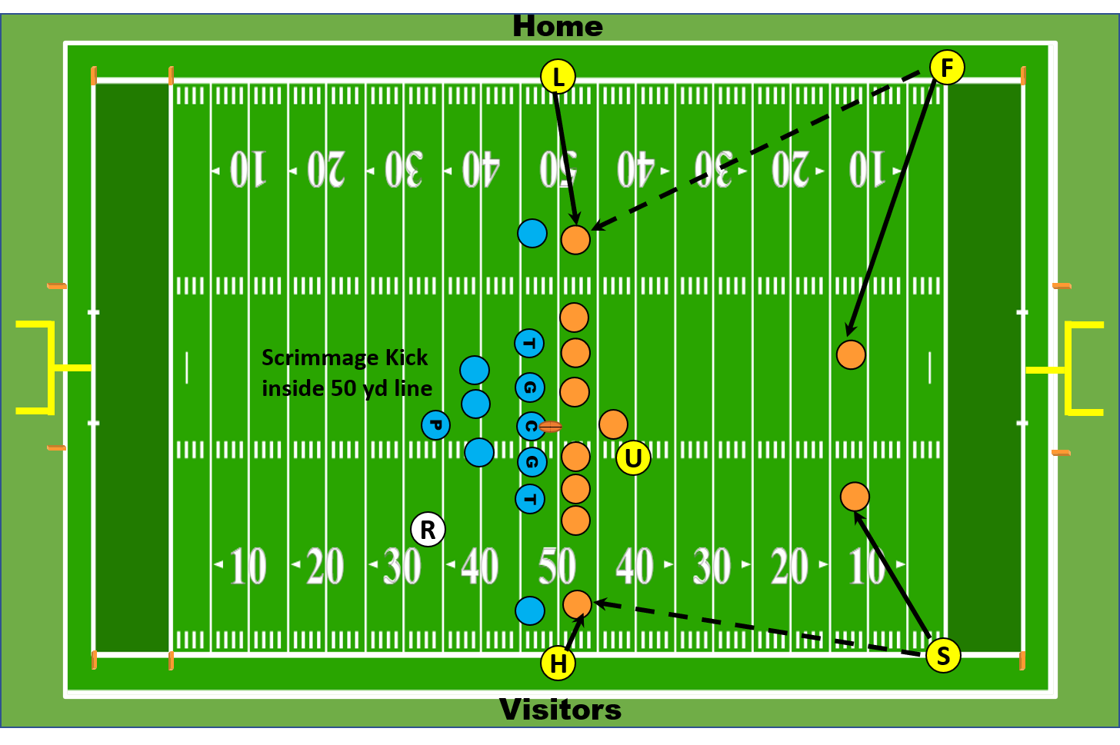

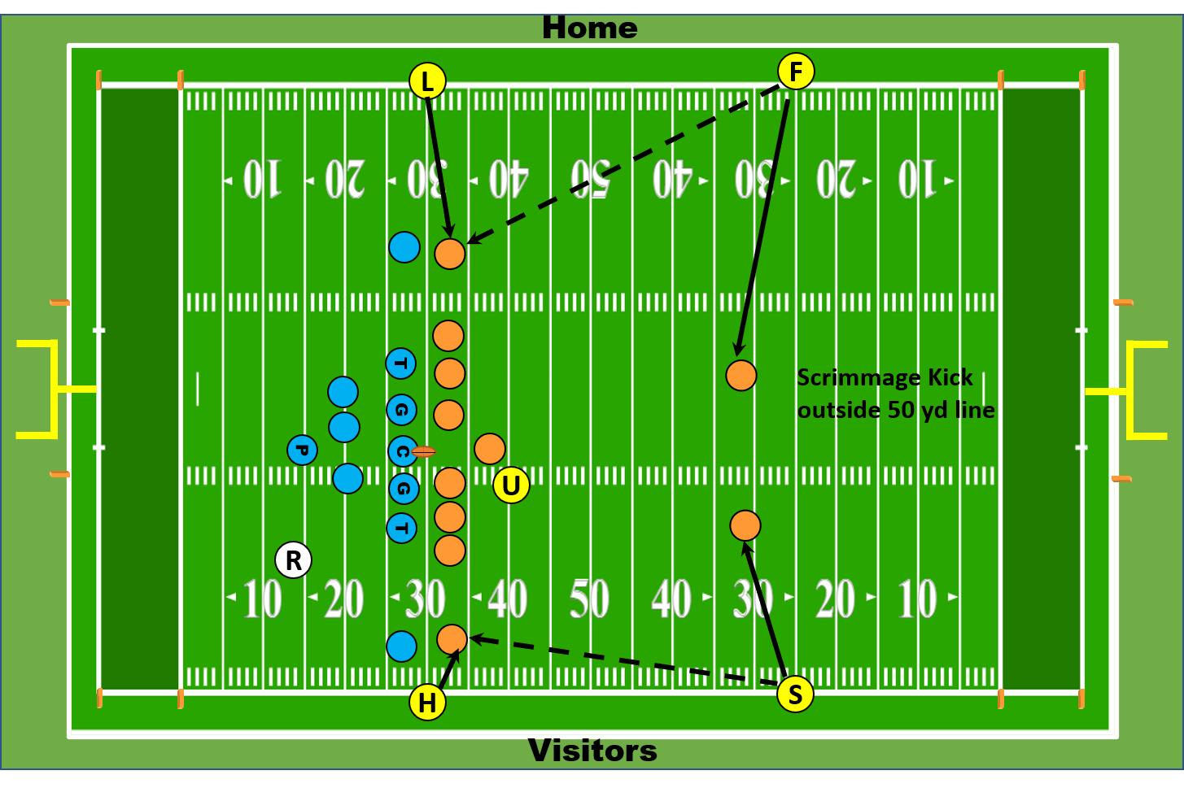

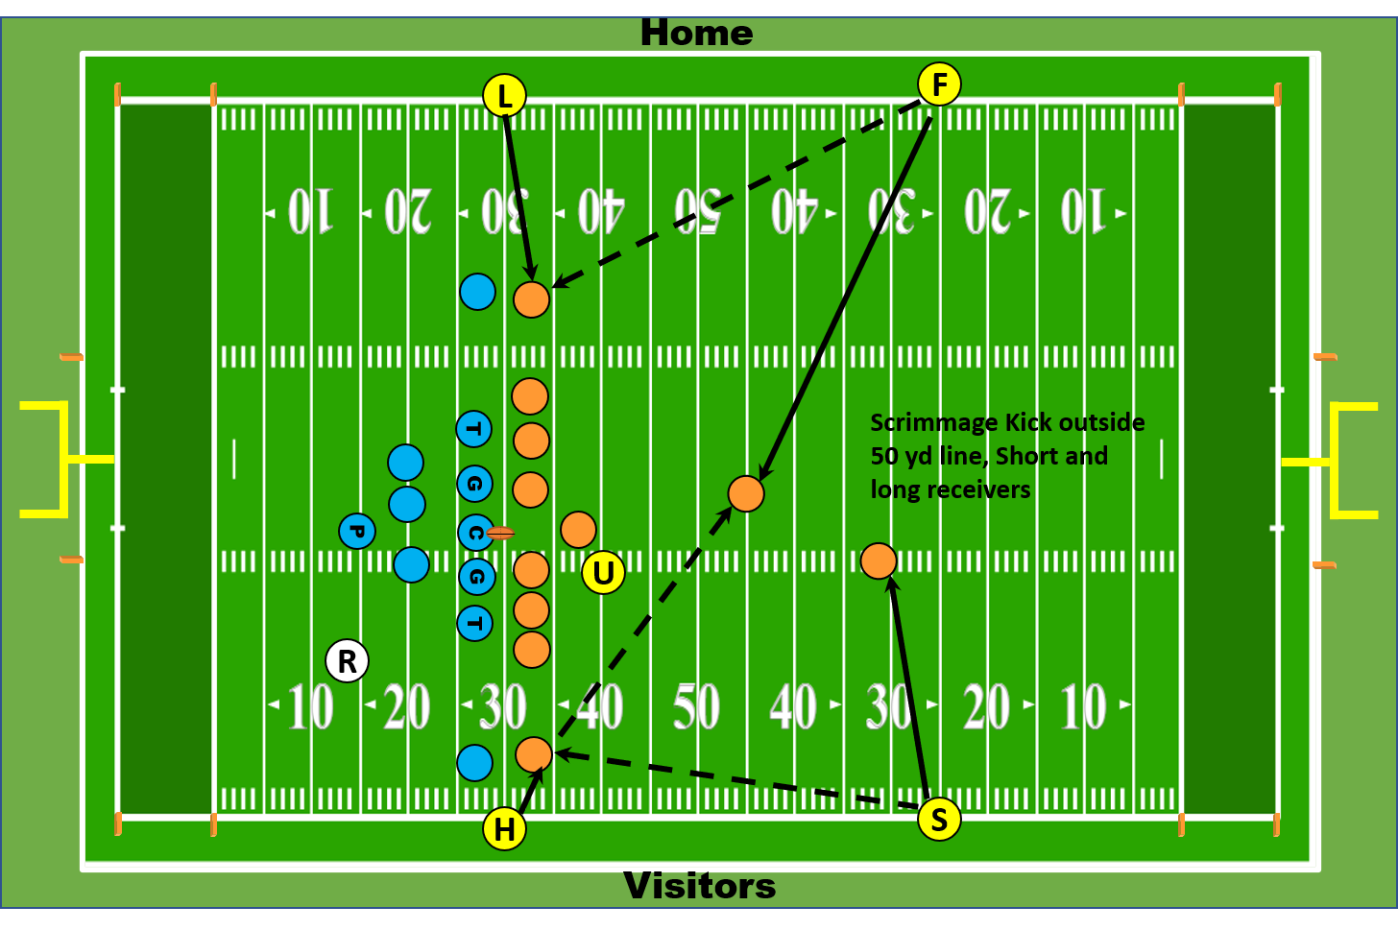

Referee:

• You are the sole guardian of the kicker.

• Verbally alert the defenders when the kick is gone.

• Watch for fouls behind the neutral zone.

• Be alert for a blocked kick - rule on recovery.

• Check with the other officials as to whether the ball was touched beyond the neutral zone.

• Don't be too quick to move downfield after the scrimmage kick. You have secondary responsibility for the K’s goal line on long returns.

• Use hand signals with the deep official on kicks that go out-of-bounds while in the air.

• Be sure you know where K’s goal and end lines are at all times and be prepared to rule on force.

• Penalty Responsibilities:

* + Holding behind the neutral zone (Rules 9-2-1c and 9-2-3d)
  + Roughing the kicker or holder (Rule 9-4-4)
  + Roughing the snapper (Rule 9-4-5)
  + Illegal blocking technique on deep runbacks (Rules 9-2-1a and 9-2-3a)

Umpire:

• A blocked kick is a live ball.

• Check down and distance with the Referee and down box before the snap.

• Check who is ineligible on the line. The numbering exceptions, based on down, apply on scrimmage kick formations.

• Prevent unnecessary roughness on the snapper.

• At the snap observe the action on the snapper and then of the guards.

• You must be in position to rule on whether the ball was touched and, if so, whether touching was beyond the neutral zone expanded.

• You must know whether the kick ended beyond the neutral zone expanded.

• After the ball is kicked, pivot to the Line Judge's side to observe blocks. Drift downfield slowly toward return observing players between you and the ball carrier.

• Remember to officiate from inside out.

• Penalty Responsibilities:

* + Roughing the snapper (Rule 9-4-5)
  + Illegal numbering (Rule 7-2-5b, Exceptions 1 and 2)
  + Ineligible receiver downfield (Rules 7-5-6 and 10-1-6)
  + Illegal blocking technique on deep runbacks (Rules 9-2-1a and 9-2-3a)
  + Clipping (Rule 9-3-5)

Linesman:

• Count the A players.

• A blocked kick is a live ball.

• Officiate at the line until the ball is cleanly snapped then release downfield 5-10 yards. Observe actions of up receivers for short kicks. Assist deep officials to observe action on the gunners for deep kicks.

• You must know: Did the ball touch a player or the ground beyond the neutral zone? If so, where? Who touched it?

• Stay on the sideline. Do not cheat in or be caught inside. Be especially alert for reverses. Keep the action in front of you and maintain a 10-yard cushion ahead of the ball carrier.

• If the kick rolls out-of-bounds, move immediately to the spot where the ball crossed the line, then give the stop clock signal.

• Execute reverse mechanics after change of possession. You have goal line responsibility. If the kick is returned to your side of the field, maintain a buffer in front of the ball carrier and observe actions in front of the runner. If the return is to the other side, clean up actions away from and ahead of the ball carrier.

• Make sure the chain crew does not move until the Referee gives his signal.

• Penalty Responsibilities:

* + Encroachment (Rules 6-1-4, 7-1-1, 2, 3)
  + Illegal procedure (Rule 7-2-1, 2, 3, 7)
  + Illegal blocking technique (Rules 9-2-1a and 9-2-3a)
  + Illegal use of hands (Rule 9-2-3b, d)

Line Judge:

• Count the A players.

• A blocked kick is a live ball.

• Officiate at the line until after the ball is cleanly kicked downfield and crosses the line, then release from the line of scrimmage drifting 5-10 yards downfield . Be alert for short kicks near the expanded neutral zone. Assist deep officials to observe action on the gunners for deep kicks.

• You are responsible for the action on and by the up receivers.

• Stay on the sideline. Do not cheat in or be caught inside. Be especially alert for reverses. Keep the action in front of you and maintain a 10-yard cushion ahead of the ball carrier.

• If the kick rolls out-of-bounds, move immediately to the spot where the ball crossed the line, then give the stop the clock signal.

• Execute reverse mechanics after change of possession. You have goal line responsibility. If the kick is returned to your side of the field, maintain a 10-yard cushion ahead of the ball carrier and observe actions in front of the runner. If the return is to the other side, clean up actions away from and ahead of the ball carrier.

• Penalty Responsibilities

* + Encroachment (Rules 6-1-4, 7-1-1, 2, 3)
  + Illegal procedure (Rule 7-2-1, 2, 3, 7)
  + Illegal blocking technique (Rules 9-2-1a and 9-2-3a)
  + Illegal use of hands (Rule 9-2-3b, d)

Field Judge:

• Have your beanbag in your hand and mark first touching by K and the end of the kick.

• A blocked kick is a live ball. Communicate with the other crewmembers about this before the snap.

• Position yourself five yards behind the deepest receiver and on the sideline on the Line Judge’s side of the field.

* Starting position on kicks inside the 50-yard line is R’s Goal Line

• On short kicks of 20-yards or less, retrieve and relay the ball.

• Be alert for:

• Illegal batting by K.

• Illegal or invalid fair catch signal.

• Runner's knee touching the ground.

• Interference with the opportunity to make the catch, whether or not the receiver signals fair catch.

• Momentum rule inside the five-yard line.

• Fumble vs muff.

• Be sure to mark the spot before communicating with the Referee regarding ball position and clock status.

• If the ball is kicked out-of-bounds on the fly, give the stop the clock signal, and move up the sideline. Go beyond the point where the ball crossed the sideline, turn back towards the Referee and respond to his hand signals.

• If the kick rolls out-of-bounds, move immediately to the spot where the ball crossed the line, then give the stop the clock signal.

• If the kick is fielded and returned, trail the ball carrier up-field until the runner crosses into the wing official's zone, then clean up behind the ball carrier. You have the spot for the end of the run to the 2-yard line.

• Penalty Responsibilities:

* + Illegal blocking technique (Rules 9-2-1a and 9-2-3a)
  + Illegal use of hands (Rule 9-2-3b, d)
  + Invalid or illegal fair catch signal (Rule 6-5-7, 8)
  + Kick catching interference (Rule 6-5-6)
  + Blocking after giving valid or invalid fair catch signal (Rule 6-5-1)

Side Judge:

• Have your beanbag in your hand.

• A blocked kick is a live ball. Communicate with the other crewmembers about this before the snap.

• Position yourself five yards behind the deepest receiver and on the sideline on the Linesman side of the field.

* Starting position on kicks inside the 50-yard line is R’s Goal Line

• On short kicks of 20-yards or less, retrieve and relay the ball.

• Be alert for:

• Illegal batting by K.

• Illegal or invalid fair catch signal.

• Runner's knee touching the ground.

• Interference with the opportunity to make the catch, whether or not the receiver signals fair catch.

• Momentum rule inside the five-yard line.

• Fumble vs muff.

• Be sure to mark the spot before communicating with the Referee regarding ball position.

• If the ball is kicked out-of-bounds on the fly, give the stop the clock signal, and move up the sideline. Go beyond the point where the ball crossed the sideline; turn back towards the Referee and respond to his hand signals.

• If the kick rolls out-of-bounds, move immediately to the spot where the ball crossed the line, then give the stop the clock signal.

• If the kick is fielded and returned, trail the ball carrier up-field until the runner crosses into the wing official's zone, then clean up behind the ball carrier. You have the spot for the end of the run to the 2-yard line.

• Penalty Responsibilities:

* + Illegal blocking technique (Rules 9-2-1a and 9-2-3a)
  + Illegal use of hands (Rule 9-2-3b, d)
  + Invalid or illegal fair catch signal (Rule 6-5-7, 8)
  + Kick catching interference (Rule 6-5-6)
  + Blocking after giving valid or invalid fair catch signal (Rule 6-5-1)

**GOAL LINE PLAYS:**

**GOAL LINE PLAY INSIDE THE 7-YARD LINE:**

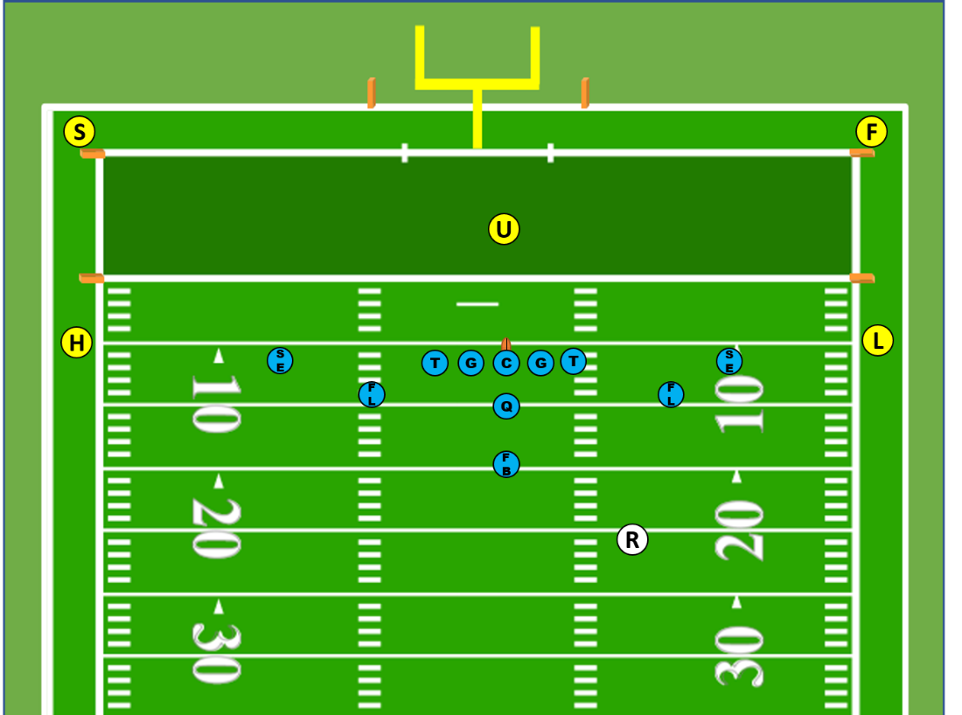

Referee:

• Do not signal score until the covering official does so first and you have scanned the field to ensure there are no penalty flags.

• Once the whistle has sounded on a run, close quickly toward the pile making eye contact with the wing officials to determine progress and/or score.

• Penalty Responsibilities:

* + Illegal motion (Rules 7-2-6, 7)
  + Illegal shift (Rules 7-2-6, 7)
  + Illegal act by snapper (Rules 7-1-2, 3, 7-2-4)
  + False start (Rules 7-1-7)
  + Illegal formation or procedure at the snap (7-2-1, 2, 3)

Umpire:

• Do not signal score on running plays.

• On a tight surge into the line, be especially alert to assist with the forward progress spot.

• Penalty Responsibilities:

* + Illegal act by snapper (Rules 7-1-2, 3, 7-2-4)
  + False start (Rules 7-1-7)
  + Illegal formation or procedure at the snap (7-2-1, 2, 3)
  + Illegal use of hands/holding (Rules 9-2-1b, c, 9-2-3b, c, d)
  + Disconcerting acts (Rule 7-1-9)

Linesman:

• Count the A players.

• Position yourself the same as a running play. You are responsible for the goal line when ball is snapped on or inside Team B’s seven-yard line. Upon a clean snap, move towards goal line immediately. Stay ahead of the runner. Officiate from the goal line back to the ball, be alert for a pass.

• You have sole responsibility for the goal line on your side and signaling for score or short on plays to your side.

• Pinch in fast on runs into the middle and find the ball. If you see it, sell it -- but don't call it if you don't see it.

• Stay out-of-bounds on the sideline. Close in only after you are positive the play has gone into the line or away from you.

• When the ball becomes dead on your side, mark the forward progress spot.

• Do not give a signal (visual or verbal) until you are positive you see a touchdown - SEE THE BALL CROSS THE GOAL LINE PLANE.

• Be prepared to assist the Side Judge on all plays, especially passes into the end zone.

• Penalty Responsibilities:

* + Illegal substitution (Rule 3-7)
  + Illegal participation (Rule 9-6)
  + False start (Rules 7-1-7)
  + Encroachment (Rule 6-1-4)
  + Illegal formation or procedure at the snap (7-2-1, 2, 3)
  + Sideline warning/interference (Rule 9-8-1k, 3)
  + Illegal motion (Rule 7-2-7)
  + Failure to properly wear required equipment (Rule 3-6-2d)

Line Judge:

• Count the A players.

• Position yourself the same as a running play. You are responsible for the goal line when ball is snapped on or inside Team B’s seven-yard line. Upon a clean snap, move towards goal line immediately. Stay ahead of the runner. Officiate from the goal line back to the ball, be alert for a pass.

• You have sole responsibility for the goal line on your side and signaling for score or short on plays to your side.

• Pinch in fast on runs into the middle and find the ball. If you see it, sell it -- but don't call it if you don't see it.

• Stay out-of-bounds on the sideline. Close in only after you are positive the play has gone into the line or away from you.

• When the ball becomes dead on your side, mark the forward progress spot.

• Do not give a signal (visual or verbal) until you are positive you see a touchdown - SEE THE BALL CROSS THE GOAL LINE PLANE.

• Be prepared to assist the Field Judge on all plays, especially passes into the end zone.

• Penalty Responsibilities:

* + Illegal substitution (Rule 3-7)
  + Illegal participation (Rule 9-6)
  + False start (Rules 7-1-7)
  + Encroachment (Rule 6-1-4)
  + Illegal formation or procedure at the snap (7-2-1, 2, 3)
  + Sideline warning/interference (Rule 9-8-1k, 3)
  + Illegal motion (Rule 7-2-7)
  + Failure to properly wear required equipment (Rule 3-6-2d)

Field Judge:

• You have responsibility for the end line. Starting position is at endline / sideline pylon. Pinch in along endline for passes to the middle or Side Judge side.

• Do not signal touchdown on running plays.

• Count B players.

• Penalty Responsibilities:

* + Illegal substitution (Rule 3-7)
  + Illegal participation (Rule 9-6)
  + Delay of game (Rule 3-6-2)
  + Illegal use of hands (Rule 9-2-3b and d)
  + Offensive pass interference (Rule 7-5-10)
  + Defensive pass interference (Rule 7-5-10)

Side Judge:

• You have responsibility for the end line. Starting position is at endline / sideline pylon. Pinch in along endline for passes to the middle or Field Judge side.

• Do not signal touchdown on running plays.

• Count B players.

• Penalty Responsibilities:

* + Illegal substitution (Rule 3-7)
  + Illegal participation (Rule 9-6)
  + Illegal use of hands (Rule 9-2-3b and d)
  + Offensive pass interference (Rule 7-5-10)
  + Defensive pass interference (Rule 7-5-10)

**GOAL LINE PLAY INSIDE 25-YARD LINE BUT OUTSIDE THE 7-YARD LINE:**

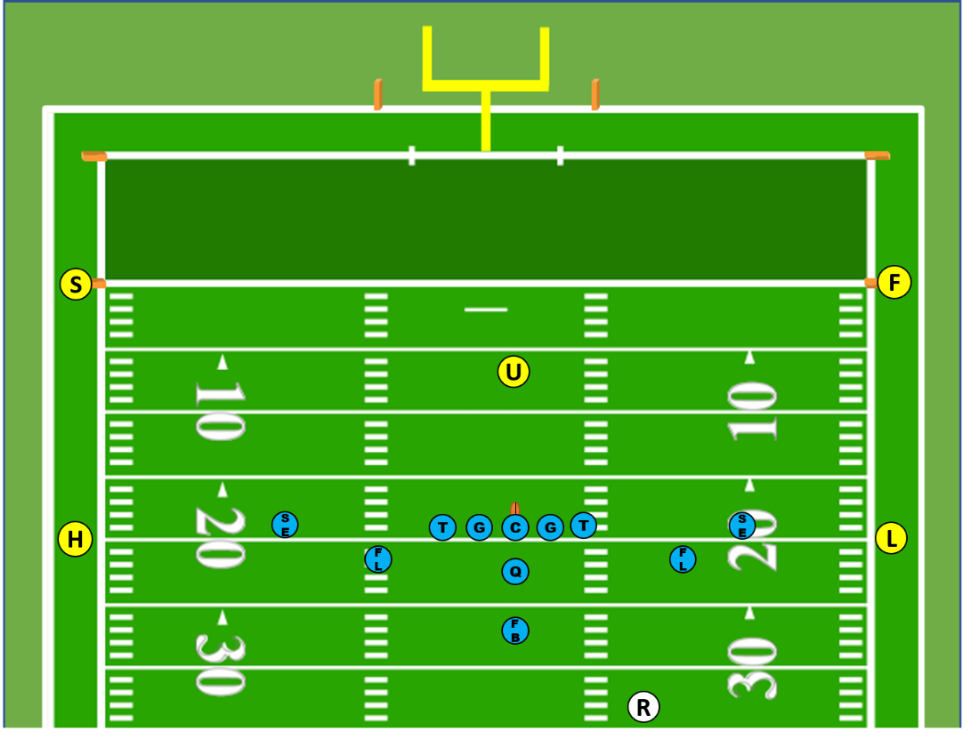

Referee:

• Do not signal score until the covering official does so first and you have scanned the field to ensure there are no penalty flags.

• Once the whistle has sounded on a run, close quickly toward the pile making eye contact with the wing officials to determine progress and/or score.

• Penalty Responsibilities:

* + Illegal motion (Rules 7-2-6, 7)
  + Illegal shift (Rules 7-2-6, 7)
  + Illegal act by snapper (Rules 7-1-2, 3, 7-2-4)
  + False start (Rules 7-1-7)
  + Illegal formation or procedure at the snap (7-2-1, 2, 3)

Umpire:

• Do not signal score on running plays.

• On a tight surge into the line, be especially alert and prepared to assist with the forward progress spot.

• Penalty Responsibilities:

* + Illegal act by snapper (Rules 7-1-2, 3, 7-2-4)
  + False start (Rules 7-1-7)
  + Illegal formation or procedure at the snap (7-2-1, 2, 3)
  + Illegal use of hands/holding (Rules 9-2-1b, c, 9-2-3b, c, d)
  + Disconcerting Acts (Rule 7-1-9)

Linesman:

• Count the A players.

• Position yourself the same as a running play, but emphasis is on forward progress to the 2-yard line.

• Pinch in fast on runs into the middle and find the ball. Confirm runner remained inbounds with Side Judge on scoring plays.

• Stay out-of-bounds on the sideline. Close in only after you are positive the play has gone into the line or away from you.

• When the ball becomes dead on your side, mark the forward progress spot.

• Be prepared to assist the Side Judge on all plays, especially passes into the end zone.

• Penalty Responsibilities:

* + Illegal substitution (Rule 3-7)
  + Illegal participation (Rule 9-6)
  + False start (Rules 7-1-7)
  + Encroachment (Rule 6-1-4)
  + Illegal formation or procedure at the snap (7-2-1, 2, 3)
  + Sideline warning/interference (Rule 9-8-1k, 3)
  + Illegal motion (Rule 7-2-7)
  + Failure to properly wear required equipment (Rule 3-6-2d)

Line Judge:

• Count the A players.

• Position yourself the same as a running play, but emphasis is on forward progress to the 2-yard line.

• Pinch in fast on runs into the middle and find the ball. Confirm runner remained inbounds with Field Judge on scoring plays.

• Stay out-of-bounds on the sideline. Close in only after you are positive the play has gone into the line or away from you.

• When the ball becomes dead on your side, mark the forward progress spot.

• Be prepared to assist the Field Judge on all plays, especially passes into the end zone.

• Penalty Responsibilities:

* + Illegal substitution (Rule 3-7)
  + Illegal participation (Rule 9-6)
  + False start (Rules 7-1-7)
  + Encroachment (Rule 6-1-4)
  + Illegal formation or procedure at the snap (7-2-1, 2, 3)
  + Sideline warning/interference (Rule 9-8-1k, 3)
  + Illegal motion (Rule 7-2-7)
  + Failure to properly wear required equipment (Rule 3-6-2d)

Field Judge:

• Count B players.

• Initial position is on goal line well out of bounds at the pylon (but always positioned deeper than the deepest defensive back). Move as the play dictates.

• Be alert. Be ready to rule on loose ball plays, rule on force, momentum and on recovery in the end zone.

• Responsible for goal line on running plays when the line of scrimmage is beyond the 7-yard line.

• Protect the end line. Be able to determine whether a catch of pass was made inside or outside of end line. Watch for eligible receivers going over the end line before they catch or touch a pass.

• You have co-responsibility for the end line.

• Penalty Responsibilities:

* + Illegal substitution (Rule 3-7)
  + Illegal participation (Rule 9-6)
  + Delay of game (Rule 3-6-2)
  + Illegal use of hands (Rule 9-2-3b and d)
  + Offensive pass interference (Rule 7-5-10)
  + Defensive pass interference (Rule 7-5-10)

Side Judge:

• Count B players.

• Initial position is on goal line well out of bounds at the pylon (but always positioned deeper than the deepest defensive back). Move as the play dictates.

• Be alert. Be ready to rule on loose ball plays, rule on force, momentum and on recovery in the end zone.

• Responsible for goal line on running plays when the line of scrimmage is beyond the 7-yard line.

• Protect the end line. Be able to determine whether a catch of pass was made inside or outside of end line. Watch for eligible receivers going over the end line before they catch or touch a pass.

• You have co-responsibility for the end line.

• Penalty Responsibilities:

* + Illegal substitution (Rule 3-7)
  + Illegal participation (Rule 9-6)
  + Illegal use of hands (Rule 9-2-3b and d)
  + Offensive pass interference (Rule 7-5-10)
  + Defensive pass interference (Rule 7-5-10)

**FIELD GOALS AND TRY FOR POINT:**

**SCORING KICK FROM ON OR INSIDE** **20-YARD LINE:**

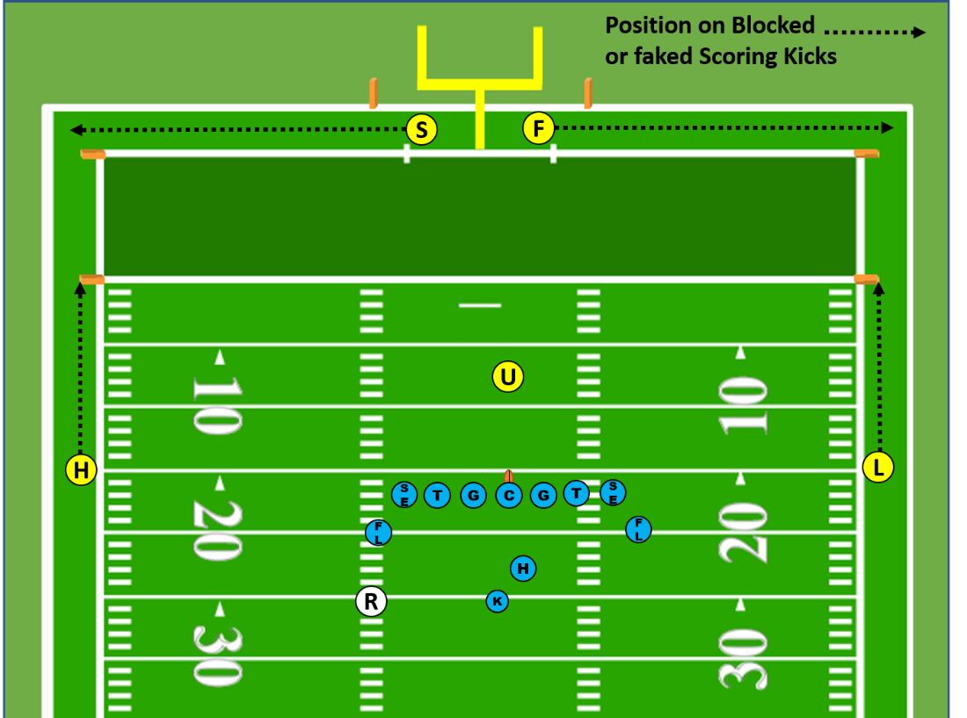

**SCORING KICK FROM OUTSIDE 20-YARD LINE:**

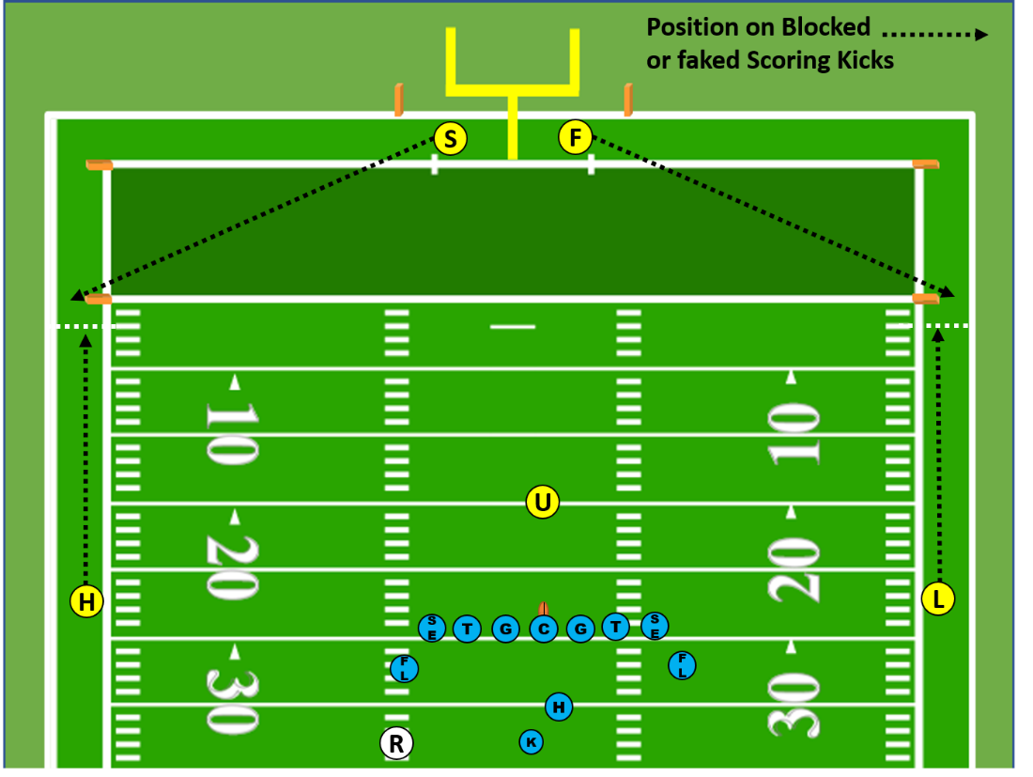

Referee:

• Confirm with umpire that officials are positioned to cover field goal, scrimmage kick try or scrimmage play try before putting ball in play.

• For a field goal or kicking try, position facing the holder, located even or slightly outside the tackle and on the same yard line as the kicker. Be prepared for fake kick or broken play.

• Position for scrimmage play if A attempting a two point try.

• Confirm with Field Judge – R has whistle for successful and unsuccessful kicking try and Field Judge has whistle on unsuccessful field goal that crosses the goal line and successful field goal.

• Do not signal successful score until the covering official does so first and you have scanned the field to ensure there are no penalty flags.

• Once the whistle has sounded on a try or field goal attempt, close quickly toward the pile or line making eye contact with the covering officials to determine progress and/or score.

• Penalty Responsibilities:

* + Roughing the kicker or holder (Rule 9-4-4)
  + Illegal shift or motion (Rule 7-2-6, 7)

Umpire:

• A blocked kick is a dead ball on a try but a live ball on field goals. Communicate this to the other crewmembers verbally and by signal before the snap.

• Position yourself two to five yards deep to observe the snapper, if two-point attempt, take normal scrimmage position.

• You must know the numbers of the ineligible receivers in a scrimmage kick formation. Identify and announce ineligible players on radio to the crew.

• After the snap, step toward the neutral zone reading the interior linemen.

• Protect the snapper.

• You must know whether the ball was touched and, if so, whether touching was beyond the neutral zone expanded.

• On field goal attempts, after the ball is kicked, be prepared to drift downfield slowly in the event of an unsuccessful kick is returned by R.

• Assist linesman and line judge in goal line coverage if a broken play develops.

• Penalty Responsibilities:

* + Roughing the snapper (Rule 9-4-5)
  + Illegal blocking technique (Rules 9-2-1a and 9-2-3a)
  + Illegal use of hands (Rules 9-2-1a and 9-2-3b, d)
  + Disconcerting acts (Rule 7-1-9)
  + Ineligible receivers illegally downfield (Rule 7-5-12)

Linesman:

• Count the A players.

• A blocked kick is a live ball on field-goal attempts. Communicate this to the other crewmembers before the snap.

• Your responsibility is the neutral zone on your side of the center.

• You have responsibility for the goal line on a fake kick or broken play during a field goal or try from inside the 20-yard line.

• Penalty Responsibilities:

* + Illegal substitution (Rule 3-7)
  + Illegal participation (Rule 9-6)
  + False start (Rules 7-1-7)
  + Encroachment (Rule 6-1-4)
  + Illegal formation or procedure at the snap (7-2-1, 2, 3)
  + Illegal blocking technique (Rules 9-2-1a and 9-2-3a)
  + Illegal use of hands (Rules 9-2-1a and 9-2-3b, d)

Line Judge:

• Count the A players.

• A blocked kick is a live ball on field goals. Communicate this to the other crewmembers before the snap.

• Your responsibility is the neutral zone on your side of the center.

• You have responsibility for the goal line on a fake kick or broken play during a field goal or try from inside the 20-yard line.

• Penalty Responsibilities:

* + Illegal substitution (Rule 3-7)
  + Illegal participation (Rule 9-6)
  + False start (Rules 7-1-7)
  + Encroachment (Rule 6-1-4)
  + Illegal formation or procedure at the snap (7-2-1, 2, 3)
  + Illegal blocking technique (Rules 9-2-1a and 9-2-3a)
  + Illegal use of hands (Rules 9-2-1a and 9-2-3b, d)

Field Judge:

• Your position is behind the end line aligned directly with the upright on the Line Judge’s side of the field. You are responsible for this upright and the crossbar.

• You are responsible for the whistle on a successful field goal and an unsuccessful field goal that breaks the plane of the goal line. A blocked kick is a live ball on field goals.

• You have responsibility for the end line on a fake kick or broken play during a field goal or try from inside the 20-yard line.

• You have responsibility for the goal line on a fake kick or broken play during a field goal or try from on or outside the 20-yard line.

• Penalty Responsibilities:

* + Illegal substitution (Rule 3-7)
  + Illegal participation (Rule 9-6)
  + Delay of game (Rule 3-6-2)

Side Judge:

• Your position is behind the end line aligned directly with the upright on the Linesman’s side of the field. You are responsible for this upright.

• A blocked kick is a live ball on field goals. Assist Field Judge with ruling a whether unsuccessful field goal breaks the plane of the goal line.

• You have responsibility for the end line on a fake kick or broken play during a field goal or try from inside the 20-yard line.

• You have responsibility for the goal line on a fake kick or broken play during a field goal or try from on or outside the 20-yard line.

• Penalty Responsibilities:

* + Illegal substitution (Rule 3-7)
  + Illegal participation (Rule 9-6)

**AFTER THE GAME:**

All Officials:

• After the Referee signals the end of the game, exit the field as a crew expeditiously.

• Ensure officials have all gear.

• Do not discuss game with coaches, players or media.

• Meet with Referee to review sportsmanship ratings, any unusual situations, unsportsmanlike fouls and disqualifications away from game administration, spectators, media and teams.

• Referee finalize and submit a description of significant unsportsmanlike and disqualifying incidents to the Commissioner as soon as possible after the game.

• Referee finalize and submit sportsmanship, game and penalty reports plus complete probationary official’s evaluations.

• Review game film on HUDL when available.