***SOUTHEASTERN***

***FOOTBALL OFFICIALS***

***ASSOCIATION***



***Football Officials Manual***

* ***Standards of Officiating***
* ***Probationary Official Policy***

***July 2021***

***www.sefoa.net***

***https://www.facebook.com/sefoafootball/***

**1. Preface.** The Southeastern Football Officials Association (SEFOA) Board of Directors (BOD) would like to welcome members and probationary officials back for the season.

**a.** Officiating is a great way to give back to the game of football. The members of SEFOA are committed to excellence in high school football officiating and are dedicated to a standard of self-discipline that is second to none in the Commonwealth of Virginia. As both players and coaches spend countless hours preparing for football games so too must officials.

**b.** The on-field professionalism of our crews starts with the strengths of each individual member. With this in mind, this manual provides guidance to assist members and probationary officials as they strive to achieve ever greater levels of excellence in high school football officiating. This also allows the Association to better serve the youth of the Virginia High School League (VHSL) and Virginia Independent Schools Athletic Association (VISAA) as well as prepare officials for advancement within the Association and to higher levels of officiating.

**2. Applicability.**

**a.** This manual achieves three purposes for members and probationary officials of the SEFOA. First, it presents officiating ethics and some general thoughts and observations on what it takes to become a good official. Second, it contains an overview of SEFOA policies, officiating standards and guidelines governing individual conduct, both on and off the field. Third, it presents an overview of Association administrative procedures.

**b.** It is intended for use in conjunction with the SEFOA 5-man and 6-man Mechanics Manual, Collegiate Commissioners Association (CCA) Football Officiating Manual for Crew of 7 and 8 with SEFOA exceptions, the National Federation of State High School Associations (NFHS) Football Rules and Case Books, VHSL and VISAA guidelines and the SEFOA Constitution & By-Laws. Football rules, rules application, detailed on-field mechanics and requirements are covered in these other publications. We strongly suggest that you also familiarize yourself with the contents of these documents. If there is a conflict between this manual and the SEFOA Constitution & By-Laws, the Constitution & By-Laws take precedence.

**3. NFHS Officials Code of Ethics.** Officials at interscholastic athletic events are participants in the educational development of high school students. As such, they must exercise a high level of self-discipline, independence and responsibility. The purpose of this Code is to establish guidelines for ethical standards of conduct for all interscholastic officials.

* Officials shall master both the rules of the game and the mechanics necessary to enforce the rules, and shall exercise authority in an impartial, firm and controlled manner.
* Officials shall work with each other and their state associations in a constructive and cooperative manner.
* Officials shall uphold the honor and dignity of the profession in all interaction with student-athletes, coaches, athletic directors, school administrators, colleagues, and the public.
* Officials shall avoid the use alcohol and tobacco products beginning with arrival at the competition site until departure following the completion of the contest.
* Officials shall prepare themselves both physically and mentally, shall dress neatly and appropriately, and shall comport themselves in a manner consistent with the high standards of the profession.
* Officials shall be punctual and professional in the fulfillment of all contractual obligations.
* Officials shall remain mindful that their conduct influences the respect that student-athletes, coaches and the public hold for the profession.
* Officials shall, while enforcing the rules of play, remain aware of the inherent risk of injury that competition poses to student-athletes. Where appropriate, they shall inform event management of conditions or situations that appear unreasonably hazardous.
* Officials shall take reasonable steps to educate themselves in the recognition of emergency conditions that might arise during the course of competition.
* Officials shall maintain an ethical approach while participating in forums, chat rooms and all forms of social media.

## 4. SEFOA Officials Code of Ethics. "I am an important part of national and state athletic programs, and pledge to act in accordance with these principles. I will:"

* honor all contracts regardless of any possible inconvenience or financial loss.
* study the rules of the game and mechanics, observe the work of other officials and at all times, attempt to improve myself and my crew.
* remember that while my work as an official is important, I must conduct myself in such a way that attention is not drawn to me but to the players of the game.
* dress and maintain my appearance in a manner befitting the dignity and importance of the game.
* shape my character and conduct myself so as to be a worthy example to the players under my jurisdiction.
* be fair and unbiased in my decisions, rendering them without regard to the score.
* give my complete cooperation to the schools which I serve and to the state and local association which I represent.
* not accept a game assignment which involves a school at which I have a conflict of interest as outlined in VHSL’s Officials Association Guidebook.
* always make every attempt to be on time and prepared physically and mentally to administer the game.
* refrain from engaging the media in discussions concerning any team, game, call, coach or fellow official.
* cooperate and be professional in my association with my fellow officials and will do nothing to cause them public embarrassment.
* be firm in my actions on the field but not overbearing; courteous, but not ingratiating; positive, but never rude; dignified, but never arrogant; friendly, but not companionable; calm, but always alert.
* keep in mind that the game is more important than the wishes of any individual player, coach or the ambitions of any individual official.
* not use tobacco products or drink alcoholic beverages on or in the vicinity of the playing field and refrain from alcoholic beverages on the day prior to game day.
* not give any information which might be used by a team's future opponent nor socialize with any player or coach during a time-out.
* act as an ambassador for officiating and comply with SEFOA BOD Policy on Social Media Use.

**5. What Makes a Good Official?**

**a.** As players need a blend of physical and mental skills to perform well, a highly effective official requires a wide range of skills. To the outsider, those skills may seem contradictory at times. As an example, to be a competent official one must possess the ability to blend into the background of the contest, yet have the presence to be omnipresent and authoritative when the situation calls for it. A good official understands the importance of allowing the players to ultimately decide the outcome of the game, while maintaining control within the framework of the rules of the game.

**b.** While it is vitally important that an official enforce the rules of the game, it’s equally important to understand the spirit and intent in which the rules are written. Officials should make the calls necessary to administer the game fairly, enhance the safety of the competitors and maintain a flow to the game while keeping in mind that the players, coaches and fans did not come to the game to watch the officials.

**c.** Athletic competition creates a high level of emotion from players, coaches, and fans. The mere elements of scoring and timing within the geographic confines of the playing field/arena generate excitement and disappointment. While everyone else has the propensity to lose their heads (emotionally), officials are expected to maintain a high degree of composure and emotional control. Inevitably, officials make mistakes. Good officials admit and learn from their mistakes, are focused on properly officiating the next play and make an effort to prevent them from occurring in future contests. Good officials attain success through a process of precise preparation and a commitment to the sport. Good officials have a checklist of actions that will elevate them to the top level in their chosen sport(s). SEFOA officials should make their own checklist from the following:

* Maintain good physical conditioning; hustle at all times
* Know the rules of the game – Share responsibility for rule interpretation, call quality fouls
* Know the game mechanics
* Be decisive – Indecisiveness gives the impression of uncertainty
* Stay focused at all times; keep officiating after calling a foul or the ball is dead
* Comments made by coaches and players should never influence your calls; answer coaches' questions do not react to their statements
* Shut out distractions
* Make the calls in your area of responsibility; call them as you see them
* Be a good crew member
* Do not draw attention to yourself, body language speaks louder than words
* Always give the impression of poise, calmness, and confidence
* Officials’ signals should be distinct and deliberate at all times
* Preventive officiating is a good mechanic for avoiding trouble

**6. General Crew Responsibilities and Procedures.**

**a. Crew composition:** The SEFOA uses 7-man crews (Referee, Umpire, Linesman, Line Judge, Side Judge, Back Judge and Field Judge) for Varsity contests and may add an 8th official (Center Judge) for certain contests. JV and Middle School games will use 5-man crews (Referee, Umpire, Linesman, Line Judge, and Back Judge). SEFOA crews may also use 6-man crews (Referee, Umpire, Linesman, Line Judge, Side Judge and Field Judge) in certain circumstances.

**b. Clock operator:** SEFOA may provide a VHSL certified clock operator who supplements the crew by keeping the official time. Paragraph 12 provides the instructions for football game clock operators based on NFHS and Virginia High School League (VHSL) requirements. Clock operators must be familiar with the contents of these instructions prior to each scheduled game and know the exceptions to these instructions for certain middle school games.

**1)** If assigned by SEFOA, all clock operators are required to attend the pre-game conference and check the operation of the scoreboard clock as a part of their pre-game duties. The clock operator is required to operate the clock, record team scores, and maintain down and quarter indicators – Workload permitting other scoreboard functions (yards to go, yard line, possession, timeout indicators, etc.) may be kept. The clock operator will notify the Referee immediately if there is a malfunction of the clock. The clock operator must have a back-up timing device in the event the field clock becomes inoperative.

**2)** If the clock operator is assigned by the home team, the Side Judge (Line Judge in 5-man mechanics) will verify that they hold a valid VHSL card indicating that he/she is a certified clock operator. The Side Judge (Line Judge in 5-man mechanics) will brief the clock operator prior to the game.

**3)** If any changes are made to the time remaining in the game, the Referee will communicate directly with the clock operator using any communication equipment available. The clock operator will make no changes unless directed specifically by the Referee.

**4)** If the clock operator is not certified or the game clock malfunctions, official time will be kept on the field by the Side Judge (Line Judge in 5-man mechanics) and both coaches and captains will be notified.

**c. Line to gain chain crew:** The home team will normally provide the chain crew. Occasionally, an SEFOA provided chain crew may supplement the field crew. Games and the second half will not start until the chain crew is present and rehearsed by the Head Linesman.

**d. General conduct:** The officiating crew’s primary responsibilities are to consistently and fairly apply the letter and spirit of the rules, emphasize sportsmanship, use preventive officiating, ensure the safety and welfare of participants and manage the game to ensure the focus is on the participants not on the officials. Each official shares responsibility for the proper conduct of the game and enforcement of NFHS rules, VHSL or VISAA policy and will follow the provisions of the current SEFOA prescribed Mechanics. Crew communication, understanding the flow of the game and anticipating the next call/actions based on game situations are critical to fulfilling these responsibilities. Crews must exhibit teamwork and hustle to maintain the flow of the game and form a positive impression of the officiating crew, in particular during those events when crews are most visible such as the coin toss, measurements, penalty enforcement, free kicks and time outs, to include between period activities.

**7. Personal Appearance:** It must always be remembered that personal appearance, both on and off the field, forms a first impression of the crew for the coaches, players and fans.

**a. Personal attire:** All officials and SEFOA provided clock operators shall show up at the game site in attire that reflects the professionalism of the SEFOA. A minimum of a collared shirt, slacks (no jeans), shoes and socks shall be worn (business casual). Flip-flops, sandal type shoes or shorts are not allowed.

**b. Hair:** Hair must be neatly trimmed and not touch the collar. Officials with long hair (including braids) which falls below the collar shall neatly and inconspicuously fasten, pin, or secure their hair under their cap.

**c. Facial hair:** A neatly trimmed mustache is acceptable as long as it is not cut lower than the corner of the mouth. All officials should be cleanly shaven with sideburns no lower than the bottom of the ear. There will be no beards, Elvis sideburns, soul patches (bit of hair below the lip), etc.

**d. Uniform and equipment requirements:** Check your uniform and equipment before leaving home. AII officials, in a given game, will wear the same uniform as determined by the referee.

**1) Officials’ uniform:** Officials must dress professionally and in the required uniform as outlined below:

a) VHSL approved black and white striped (2 ¼”) shirt with black knit cuffs and Byron collar, U.S. Flag on the left sleeve, VHSL logo above the left pocket and officials' number placard on the back of the shirt as shown in Figure 1 shall be worn. The Flag with blue field forward is sewn on the left sleeve and centered on the sleeve with the top edge approximately 6 1/2 inches (or mid-bicep) below the shoulder seam. The sew on placard with 6-inch gothic numbers on the back is centered with the top of placard located approximately 3 inches below shirt collar. The VHSL logo is centered 1 inch above the left breast pocket. The U.S. Flag, VHSL logo and/or number placard may either be sublimated or sewn on the shirt. A crew can wear a mixture of both sublimated and sewn on patches and still be considered "in the same uniform". Either a long or short-sleeved shirt will be worn as determined by the referee. When so designated by the BOD, a memorial device may be worn.

**FIGURE 1.**

**FLAG & VHSL EMBLEM LOCATION**

**2 1/4 " STRIPED SHIRT**

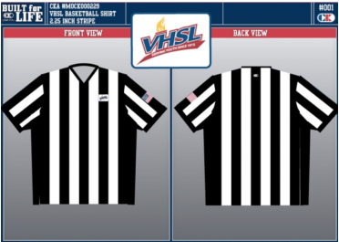

**15**

b) Black football official pants with a 1-1/4″ white high-visibility stripe down the outside of each leg shall be worn by the entire crew during SEFOA assigned games.

c) Black crew or longer socks are required.

d)Solid black shoes (preferred), with black laces, free of dirt or scuff marks.

e) Black baseball-style cap with white piping (sized) is required. For ease of identification, the referee shall wear a solid white baseball-style cap (sized).

f) A black leather belt 1 3/4 to 2 inches wide with a plain buckle shall be worn.

g) A black-and-white vertically striped jacket may be worn prior to, at half time and at the end of the game unless worn by entire crew.

h) Black Tee Shirts or Turtle Necks only. When approved by the Referee black gloves and/or black balaclavas may be worn as optional individual items.

i) The uniform should fit properly and be clean and neat.

j) During scrimmages, black officiating shorts with black belt (preferred) will be worn in place of the black football official’s pants by the entire crew. If spandex is worn, it should not extend below the shorts unless it matches the color of the shorts. Black Bermuda, officiating shorts with white stripe on side of legs or sport shorts are acceptable. Officials will also wear their regular season hat, striped shirt (number placards are optional) and shoes with black ankle socks. Regular season uniform will be worn for pre-season benefit games.

k) During October, referees may authorize wear of breast cancer awareness lanyards, bean bags, hats, wristbands and/or other items as long as the crew is uniform. For other special events, referees will check with SEFOA Commissioner for any exceptions to above uniform standards.

l) Officials will not wear sunglasses except prescription tinted or transition lenses.

**2) Officials’ equipment:**

a) All officials must have the proper equipment. Essential items include: Two whistles (with black lanyard if used; FOX 40 preferred), penalty marker, blue, black and/or white bean bags, game card, pencil and rubber bands or some device to keep track of the down number. If a mouth guard is used, it should be white.

b) A radio (walkie/talkie) is required equipment. Officials (on-field and clock operators) are required to use a RETEVIS H777 Radio, or a radio compatible to the RETEVIS, and earpiece headset with microphone for all games to facilitate crew communication and game management.

c) The penalty marker shall be a light gold flag (15 inches x 15 inches) with a middle pouch weighted with sand or beans, etc.

d) The bean bag is used to mark spots, other than the spot of a foul for future reference. The bean bag is used to mark the yard line of the spot; not a particular spot and should be dropped or tossed, not thrown if possible. Examples of when to use the bean bag are as follows: To mark first touching of a FREE or SCRIMMAGE kick, momentum on catches of passes and kicks inside the five yard line, the end of the run followed by a loose ball and the spot of the ball at the time the whistle was sounded when a whistle is sounded inadvertently as well as the spot where a scrimmage kick ended for Post Scrimmage Kick (PSK) enforcement. THE BEAN BAG IS A VALUABLE OFFICIATING TOOL BUT NOT A REPLACEMENT FOR HUSTLE – KNOW HOW TO USE IT PROPERLY PER SEFOA PRESCIBED MECHANICS.

e) The head linesman shall furnish a clipping device for use in measuring first downs or resetting chains.

f) Stop watch or other timing device (7-man crews: Back Judge/Side Judge/Field Judge; 6-man crews: Side Judge/Field Judge or 5-man crews: Back Judge/Line Judge).

g) Coin (Referee) and backup coin (Umpire).

**3) Chain crew uniform:** An SEFOA assigned chain crew will wear the official uniform with the exception that an all-black shirt shall replace the regular striped shirt. Black jackets are approved for cold weather.

**e. Suggested Uniform Sources (not only options):**

**1)** Honigs Whistle Stop: <http://www.honigs.com>

**2)** Ump-Attire: <http://www.ump-attire.com/football.html>

**3)** Purchase Officials: <http://www.purchaseofficials.com>

**4)** Cliff Keen: <http://www.cliffkeenofficials.com>

**5)** Terry's Official Call (TOC): [www.theofficialcall.com/234/index.php](http://www.theofficialcall.com/234/index.php) - VHSL official sponsor and supplier of officials' gear and VHSL-logoed merchandise

**8. Personal Conduct:**

**a. Duties and responsibilities:** Each official must have a thorough knowledge of the duties of his own position and also be fully informed concerning the duties of each of the other officials in accordance with the SEFOA prescribed mechanics. Each official should be qualified to assume any one of the other positions whenever circumstances require rearrangement of assignments. Each official must:

**1)** Not socialize with coaches, players or spectators prior to, during or after games.

**2)** Address coaches and players in a professional manner. Answer reasonable questions, but do not react to statements or emotional outbursts. Keep calm, maintain poise at all times. Although an official's judgment decisions are not subject to protest and officials must not condone conduct that is clearly unsportsmanlike, the head coach is entitled to clarify or question decisions based upon interpretations of playing rules. Officials should grant a time out if the head coach asks to talk to the referee in accordance with Rule 3-5-2c. Handle players in a fair, firm and friendly fashion. Be pleasant but firm.

**3)** Know the down, location of the ball, line-to-gain and yardage-to-gain prior to each snap andcount assigned players each down.

**4)** Know the proper signals, when they should be used, and use only the proper signals. Signal the number of the next down, to indicate that there are 11 or fewer players on the field or more than 11 players on the field and whether the widest offensive player(s) is (are) in the backfield.

**5)** If covering the runner or a loose ball, quickly and loudly sound whistle when the ball clearly becomes dead to stop action and prevent injury. Use restraint when your line-of-sight to the ball is obstructed. If the ball is declared dead out of bounds, mark the out of bounds spot, signal time out and continue to officiate players out of bounds until they return to the field of play. If the ball is declared dead in bounds near the sideline, give the appropriate signal to indicate that either that the ball is inbounds or to stop the clock if the line-to-gain is reached or if there is a penalty and communicate clock status with referee.

**6)** Assume instantly the duty of any official who is temporarily out of position. Proper position of an official is an all-important factor to successfully fulfilling prescribed mechanics.

**7)** Have courage, tact, but most importantly good judgment. Make decisions instantaneously and announce rulings without delay. Get the call right but hesitating unnecessarily is as serious as making an error. To ensure improved instinctive reaction to game situations review all possible combinations of circumstances before each play and as many as possible before each game.

**8)** Retrieve the ball quickly and be able to handle and pass the ball properly. Continue dead ball officiating and use underhand throws only.

**9)** Be alert to happenings away from the ball when the play has left your immediate area.

**10)** Upon observing an obviously injured player, signal time-out after the ball becomes dead.

**11)** Preventive officiating is best and can be accomplished with a word at the right time. Do not coach. Warn when necessary, never threaten. If you feel a situation is serious enough to warrant a threat, then it is serious enough to penalize, without invoking a threat. Establish a calm environment for the game.

**12)** Maintain a game card. Record the Captains' names and numbers, winner of the toss and options selected, ball position at the end of the first and third quarter, time outs, scores, and fouls you called (include quarter/time on clock/offending player number/team/result of penalty enforcement).

**b. Penalty enforcement:**

**1)** Officials must reinforce points of emphasis, penalize promptly all unnecessary roughness or unsportsmanlike conduct and administer the rules in an impartial and effective manner. Effective officials know the rules, understand the spirit and intent of the rules and act decisively. The prescribed CCA and SEFOA mechanics manuals provide great insight into penalty enforcement and help to put officials in the best position to observe play. Use preventive officiating when possible.

**2**) The covering official must credit the offense or team in possession with every yard of forward progress but also credit the defending team with every yard denied.

**3)** The official who sees an infraction of the rules in his zone of coverage should throw an accurate penalty marker to mark yard line of the foul, not necessary to mark the exact spot, and continue to officiate. The official throwing the penalty marker should not throw the marker in a dramatic way or significantly higher than eye level when possible.

**4)** When the down ends, stop the clock, gain the Referee’s attention and report to the Referee: type foul, spot of the foul, number and color of the jersey of offending player, status of the ball at the time of the foul (in possession, loose or dead), the basic spot (loose ball play, running play, all-but-one) and result of the play including clock status. Other officials must cover the penalty marker, previous spot, line to gain markers and end of play ball location.

**5)** The entire crew is responsible to ensure the penalty is enforced properly.

**6)** When a player commits a disqualifying foul, the covering official shall report to the Referee, the player's number and reason for disqualification. The Referee will notify the head coach that his player has been disqualified and the reason. The officials shall not touch, point at or escort any disqualified player to the sideline. The only official to give any signal concerning the disqualification of a player is the Referee. The Referee must report ALL ejections or other unusual game circumstances to the SEFOA Commissioner or other designated individual in his absence. Officials cannot “undo” an ejection, even if you realize later that there was a mistake. Officials cannot “make deals” with coaches or AD’s after the fact. The Referee will call the Commissioner immediately after the contest and follow up with a report (or completed VHSL Commissioner's Ejection Report Form) that includes game information, who was ejected, summary of all circumstances leading to ejection including the rule reference that required ejection and covering official(s) within 12 hours. As with all penalty enforcement, the crew is responsible to ensure the Referee has all ejection report information before leaving the game site.

**7)** The Referee shall make final decisions on all differences of opinions, testimony or interpretations.

**8)** Most Probationary Officials work either Linesman or Line Judge Positions. The following lists the most common infractions seen working these positions:

* + Illegal substitution
  + Free kick infraction
  + Encroachment
  + False start
  + Illegal formation
  + Face mask
  + Sideline interference
  + Holding
  + Illegal block in the back
  + Kick-catching interference
  + Forward pass interference
  + Illegal block below the waist

**c. Alcohol and tobacco products:**

**1)** Consumption of alcohol the day of a game is strictly forbidden until after departure from the game site. It is strongly recommended that officials refrain from alcohol consumption the day prior to game time.

**2)** The use of tobacco products on or in the vicinity of the playing field is prohibited.

**9. SEFOA Requirements:**

**a. General requirements:**

**1)** To be eligible to officiate VHSL contests, an official must register with VHSL and be in good standing with both VHSL and SEFOA, complete a VHSL football rules clinic, pass the current NFHS Football Rules Exam per paragraph 9.b. and complete SEFOA annual clinic mandatory requirements, pay dues and fines or meet any other criteria set by SEFOA BOD.

**2)** To register with VHSL, go to https://www.whistle.vhsl.org/official-registration/, follow the instructions and pay registration fee online.

**3)** Officials registered through VHSL receive access to NFHS resources including insurance through NFHS Football Officials Association (NFOA).

**4)** Submit a current SEFOA General Release Form.

a) General release of SEFOA.

b) Health and safety risks acknowledgement.

c) Social Media policy review.

d) As required by Section 22.1-296.1(C) of the Code of Virginia, individual contractors must certify to VHSL during registration and to SEFOA that they have never been convicted of a felony or any offense involving the sexual molestation or physical or sexual abuse or rape of a child.

**5)** Attend association meetings, with no more than 2 unauthorized absences per year. Examples of possible authorized absences are work related out of town travel; serious illness, hospitalization or death of immediate family member and SEFOA assigned games. The Association President in consultation with the Board of Directors will determine what other circumstances warrant an authorized absence.

**6)** Establish an “ArbiterPay” account.

**b. Knowledge of the rules:** Must be as near perfect as possible and must be supplemented by ability to interpret rules correctly. These abilities are acquired only through devotion, dedication, time and study. Officials must complete the VHSL clinic, in-person when required, to officiate VHSL contests. Officials must score a minimum of:

**1)** 70-74% on rules exam to be registered as Level 1 official and can officiate VHSL contests at the sub-varsity level (registered VHSL official).only.

**2)** 75-84% on rules exam to be approved for assignment as a Level 2 official and can officiate VHSL regular season varsity level (approved VHSL official).

**3)** 85% to be a Level 3 official and officiate VHSL regular season varsity and sub-varsity contests and, if selected, District, Region and State Tournament contests; also must be an SEFOA regular member to officiate post-season VHSL games.

**4)** Any official who fails to score above 70% on rules exam will be placed in probationary status for that year and is an unapproved official and may not work ANY VHSL interscholastic contests.

**c. Physical condition:** Football officiating is difficult, placing high demands on the mind and body. Officials whose eyes, ears, legs, heart, nerves or wits are not in excellent condition have no place in officiating. By-Laws require that each official complete the physical fitness requirements as set by the Board of Directors. Officials who need eyeglasses should use them and not permit false pride to decrease their efficiency on the field. All officials must complete the annual Physical Fitness Assessment.

**10. Game and other assignments:**

**a. “The ArbiterOne”:** SEFOA games are assigned via “The ArbiterOne”, located at www.arbitersports.com. All officials will:

**1)** Establish prior to the season /maintain an e-mail address and a “The ArbiterOne” account to receive game assignments.

**2)** Update “Blocks / Dates” section in “The ArbiterOne” and keep it current throughout the season.

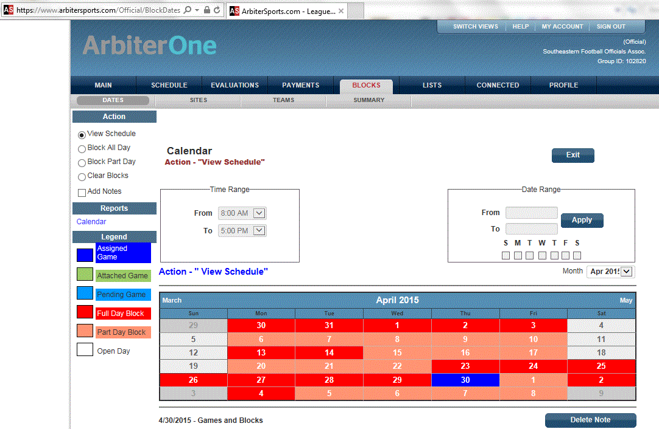

**3)** Check the “Ready To Be Assigned” box on “The ArbiterOne” main page.

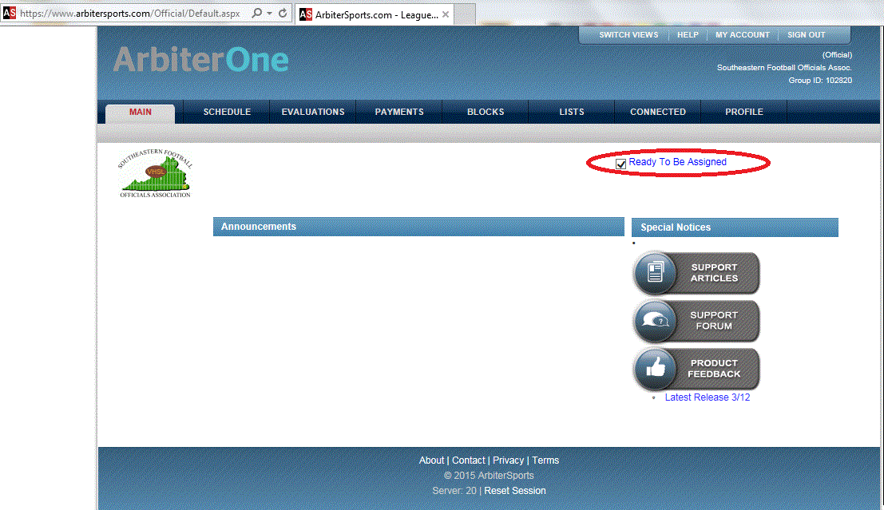

**4)** The Commissioner will assign games based on your availability. If you are assigned a game and cannot work, contact the Commissioner immediately by phone. No other form of communication is accepted.

**5)** Contact the Referee 48 hours prior to the assigned game to confirm game location, game time and your assignment; the Referee will determine exact arrival time and location to meet, pre-game conference time, which uniform is to be worn/brought, whether the crew will dress at or arrive dressed at the site, and any other pertinent information.

**6)** Review prescribed mechanics for your field assignment or NFHS instruction for football game clock operators prior to each scheduled game.

**7)** The Commissioner may assign certain officials to meet with area football teams and to discuss safety, sportsmanship and rules; the Association is required by VHSL to meet will ALL teams in our area prior to the team’s first game.

**b. Pre-Game Activities:**

**1) Travel to Game site.** Carry your game officials phone listing with you as you drive to the game. Traffic can be heavy. Allow for ample travel time. Do not assume that games are delayed or cancelled due to weather. Whenever possible you will be notified in advance if they are cancelled. If you are late or unsure of a situation, contact your Referee immediately.

**2) Arrival time.** Field officials shall arrive at the game site 90 minutes before the scheduled starting time for varsity games and not later than 45 minutes prior to other scheduled games to conduct pre-game with the Referee. Always be on time. Clock operators shall report to the officials’ dressing room at the stadium at least 60 minutes before the scheduled starting time for varsity games and not later than 45 minutes prior to other scheduled games and assume control of the clock after pre-game coordination with the crew. Clock operators should bring their game uniform and gear in case they need to fill in on the field. Be prepared. Members shall not be late arriving for a game: A disciplinary action may be imposed for each occurrence. For repeated offenses or missed games, the member will be relieved of further game assignments until such time as the BOD may rule on further eligibility.

**3) Dress for arrival at game site.** Varsity Crews usually dress at the game site for games and will arrive in personal attire per paragraph 7.a. above. When the Referee determines that the crew will arrive at the game site dressed; officials should arrive ready in game uniform except for shoes, shirt, hats etc. Do not change at the car.

**4) Assuming authority for game.** All field officials should be on the field of play no less than 30 minutes prior to the start of the game. The clock operator should be at the control board 30 minutes prior to the start of the game and have an extra stopwatch available.

**5) Guidelines for lightning or thunder disturbances.** Lightning poses a major hazard to officials, players, coaches and fans. There is a r**isk WHENEVER lightning can be seen or thunder can be heard.**  As soon as lightning is seen or thunder is heard, SEFOA Referees should invoke NFHS Football Rule Book rule 3-1-5 and follow associated procedures for lightning or thunder disturbances. Referees, in coordination with game administration, may consider host school provided lightning detector readings to inform risk decisions.

**6) Interrupted or Suspended games.** Officials will provide a minimum 15-minute warm-up period for delayed start in a contest. For an interrupted game by lightning, thunder or other events, the Referee will coordinate with host game management officials to determine resumption or suspension of the game. Officials should be prepared for up to a 90-minute delay on school nights which may be longer for delays on nights not followed by a school day. The referee will provide the Commissioner with a detailed game card status if a game is suspended. The Commissioner will attempt to schedule the same crew for the rescheduled suspended game which shall resume from the point of interruption unless both schools agree to accept the score at the time of the interruption as final.

**7) Guidelines for handling blood and other bodily fluids.** Players who are bleeding or have blood on their uniform or skin, whether their own or from another player, will be removed as an injured player and the individual’s participation shall be interrupted until team personnel address the issue per NFHS Rule 3-5-10c. It is up to the referee as to how many times the competition shall be stopped due to an athlete’s bleeding before disqualification occurs.

**8) Tie breaking procedures.** SEFOA will use NFHS Football Rule Book procedures for resolving tied games except for certain Middle School games or those terminated IAW NFHS Football Rules 3-1-4 and 3-1-5.

**9) Unsportsmanlike Conduct and Ejections.** SEFOA officials should use preventive officiating and seek assistance from captains and coaches to emphasize good sportsmanship throughout the contest. If a player or coach commits a disqualifying foul, the covering official must provide details to the Referee on the disqualifying foul. Only the Referee will signal the ejection and inform the head coach of the ejection. All officials on the crew should record the period, time, foul and number of any player or coach who commits an unsportsmanlike act in case there is a second incident during the game and will also note period, time, foul and number of the player or coach ejected on their game card. The Referee, with assistance from the covering official, must provide a description of significant unsportsmanlike and disqualifying incidents to the Commissioner as soon as possible after the game.

**10)** **Conclusion of the game:** Field officials should come together as a crew and leave the field promptly; neither seeking nor avoiding members of the coaching staffs. All officials must not give interviews or make any statements to the Press or spectators concerning the game just worked. Upon completion of the game the clock operator should leave the press box/location of clock controls as expeditiously as possible.

**11. Probationary Officials:** The probationary period for new officials is (3) three years. Experienced NFHS or VHSL officials per VHSL Sports Official's Handbook who transfer to the SEFOA are considered Year 3 probationary officials. During this period, all probationary officials must attend all general and special meetings as designated by the Training Committee.

**a. Evaluations.** Additionally, probationary officials will be evaluated, by the Referee and/or other designated official, for each game assigned by the Association. Probationary officials, with the exception of clock operators, are responsible to inform the Referee of their probationary status and need for an evaluation prior to a game. Probationary officials permanently assigned to Varsity crews will receive at least one evaluation from the Varsity Referee for the season. Referees will complete evaluations in the Evaluation section of the “The ArbiterOne” website where probationary officials may view them.

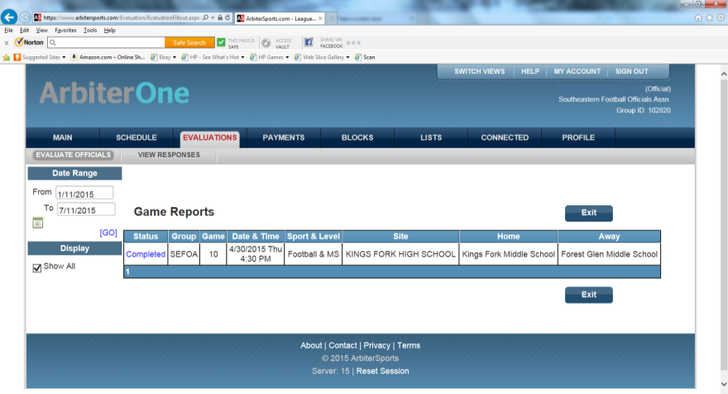

**b. Annual Probationary Reviews.** At the end of the season, the Standing Membership Committee will have a formal review regarding each probationary official. This formal review will include: Overview of overall performance and recommendation which will be forwarded for the Board of Director’s decision. Factors influencing the overall performance evaluation include:

* Evaluation Committee’s recommendation based on Game evaluations
* Training Committee's recommendation
* Training Committee's observations of games
* Test scores
* Attitude, cooperation and attendance at Training and Association meetings

**1) 1st and 2d year Probationary officials.**

* At the end of the 1st and 2nd years the Standing Membership Committee will make a recommendation on the status of each probationary official for the upcoming year. Recommendation options are:
* Advance to the next year of probation
* Repeat the current year of probation
* Drop from the Association

**2) 3d year** **Probationary officials.**

At the end of the 3rd year the Standing Membership Committee must recommend to the BOD, for their final decision, one of the following options:

* Vote into full membership
* Extend probation for (1) one additional year
* Drop from membership

**3) Year 4 Probationary officials.**

At the end of the 4th year the Standing Membership Committee must recommend to the BOD:

* Vote into full membership
* Drop from membership

**12. General Instructions for Football Game Clock Operation**

**a. Pregame.** The game clock operator and, SEFOA provided play clock operator if other than the designated on-field official, should report to the game officials at least one hour for Varsity and at least 30-minutes for other contests before game time for the following purposes.

**1)** To synchronize timer’s watch with official game time as established by the official responsible for timing.

**2)** To advise officials whether the clock operator and/or play clock operator will be in the press box or on the sideline/field. Determine procedure for communication with timer and check this procedure prior to the game.

**3)** To discuss starting, stopping and adjusting the game clock or play in accordance with the playing rules.

**4)** All pregame and halftime activities will be synchronized with the official game clock.

**5)** Game clock operator is NOT REQUIRED TO RUN TIME ON THE CLOCK BEFORE THE GAME, but must test functionality and then set clock time for 1st period (12 minutes for varsity, 10 minutes for sub-varsity and 8 minutes for games involving ONLY 8th graders) before the coin toss.

**6)** Game clock horn (mechanical signal) is to be turned off for the duration of the game.

**b. Halftime.** The halftime intermission will start on the referee’s signal when the players and/or officials leave the field and will be timed by on-field officials but not displayed on the field clock. The mandatory three-minute warm-up period will be put on the field clock after the halftime intermission time has elapsed and start on referee's signal.

**c. Clock Malfunctions.** The game clock operator shall have an extra timing device available. In case of failure of the game clock, the game clock operator shall immediately contact the officials, giving them the correct data regarding the official time. The on-field official responsible for timing will then pick up the official game time on his timing device. The game clock operator may be required to keep the time on the sideline, assuming a position near the Side Judge (7-man and 6-man mechanics) or Line Judge (5-man mechanics). If the inoperative field clock is subsequently repaired, it will not be used again until the next period or when the Referee determines it is operational. The public-address announcer will indicate the field clock will not be official until the malfunction is corrected and a subsequent announcement is made on the public-address system.

**d. Game Procedures.**

**1)** The clock operators are integral members of the officiating crew and game administration. Unfair advantages occur when the game clock is not started or stopped or the play clock not properly reset correctly by rule. Great care must be exercised to see that no time lag occurs in starting or stopping the clock.

**2)** On all free kicks, the nearest official(s) will signal the legal touching of the ball by indicating that the clock should start.

**3)** The Line Judge or the official who declares the ball dead will be the first official to signal a time-out when a first down occurs.

**4)** Any official may signal a team time-out; therefore, the operator should be alert to stop the clock.

**5)** The incompletion signal will stop the game clock. Note: On plays near the out-of-bounds line and in advance of the line to gain, an official will give the stop-the-clock signal for an apparent first down and indicate to the referee that the ball is inbounds or out-of-bounds.

**6)** The clock operator will automatically stop the clock following a touchdown, field goal, touchback or safety after the appropriate signal has been made.

**7)** After the game clock has been stopped, the referee will start it again on the referee’s start-the-clock signal and if no such signal is given, the operator will start it on the snap or touching of a free kick by R without the signal from the Referee.

**8)** The Referee may start the game clock again in certain instances before the ready-for-play signal.

**9)** The try is an untimed down.

**10)** There are instances when a period shall be extended by an untimed down. During these extensions, leave the clock at :00 but the play clock will be used. Do not reset the game clock for the next period until the referee declares the period over by facing the press box and holding the ball overhead.

**11)** When the game is extended for an overtime period to resolve a tie, there will be a three-minute intermission before the first overtime period and two-minute intermission before each subsequent overtime period. During overtime periods, leave the game clock at :00 but the play clock will be used. Only run game clock if the referee wants to time the intermissions.

**12)** Guidelines for utilizing a running clock as per VHSL Handbook and Policy FOOTBALL POINT RULE: when a thirty-five (35) point differential is reached at half-time or at any point during the second half, the game clock will continue to run anytime there is an incomplete pass, the runner goes out of bounds or the offensive team obtains a first down. Additionally, when the mercy rule is in effect and there is a:

* Change of possession the clock will stop for substitutions and setting the chains and
* then start on the "ready for play" signal.
* Score, the clock will stop for the extra point. The clock will run by rule during the subsequent free kick, then after setting the chains, started on the "ready for play" signal.
* Charged timeout, the clock will stop and then start on the "ready for play" signal following the timeout.

Should the point differential subsequently be reduced to less than thirty-five points, game officials will discontinue the use of this timing adjustment. This adoption will be utilized during regular season and playoff games and at all levels of play (varsity and sub-varsity). This adjustment may not be utilized when NFHS Football Rule 3-1-3 is in effect.

**13)** NFHS approved the 2019 football rule change to the play clock that now involves a 40-second or 25-second possibility for determining a delay of game. Unless otherwise directed by the SEFOA Commissioner, the play clock will be kept on the field (7-man crews: Back Judge; 6-man crews: Field Judge or 5-man crews: Back Judge) and when and if there are visible play clocks, they are not to be considered official.

**14)** Note to the Play Clock Operator: Start the 40-second play clock “immediately” after the covering official signals the end of the down using Signal #3 (time-out) or), Signal #7 (dead ball with one arm straight up) or), Signal #10 (incomplete pass).) or when the Referee puts the ball in play using signal #1 (ball ready for play) or #2 (start clock) after an officials’ time-out is taken for an injury to a defensive player or a defensive player has an equipment issue. The Play Clock Operator will always set the play clock back to 40 during a down in progress as the Play Clock Operator will have plenty of time to change it back to 25 at the end of the down if necessary. The 25-second play clock will be used and will start when the Referee puts the ball in play using signal #1 (ball ready for play) after a legal kick when either team is awarded a new series.